**S4 holiday exercise term2 2021**

1. Define the following terms
2. Resolving power
3. Power of the lens
4. Torque of couple of forces
5. Non-fossil fuels
6. Resistivity
7. A950 kg sack of cement is lifted to the top of a building 50m high by an electric motor.
8. Calculate the increase in the gravitational potential energy of the sack of cement.
9. The output power of the motor is 4.0kw. Calculate how long it will took to raise the sack to the top of the building.
10. The electric power transferred by the motor is 6.9 kw in raising the sack to the top of the building, how much energy wasted in the motor as heat.
11. A slide projector has a converging lens of focal length 20.0cm and is used to magnify the area of a slide, 5cm2 to an area of 0.8m2 on a screen. Calculate the distance of the slide from the projector lens.**5marks**
12. **.**A magnifying glass has a focal length of 5cm. Find the angular magnification and the position of an object if the image is formed at the position of least distinct vision of 25cm.**5marks**
13. An astronomical telescope has an objective lens of focal length 120 cm and an eye piece of focal length 5 cm. If the telescope is in normal adjustment, what is; (a) The angular magnification (magnifying power) (b) The separation of the two lenses?**5marks**
14. A uniform horizontal beam with a length of 8.00m and a weight of 200N is attached to a wall by a pin connection. Its far end is supported by a cable that makes an angle of 53.0° with the beam. If a 600N person stands 2.00m from the wall, find the tension in the cable as well as the magnitude and direction of the force exerted by the wall on the beam.**15marks**

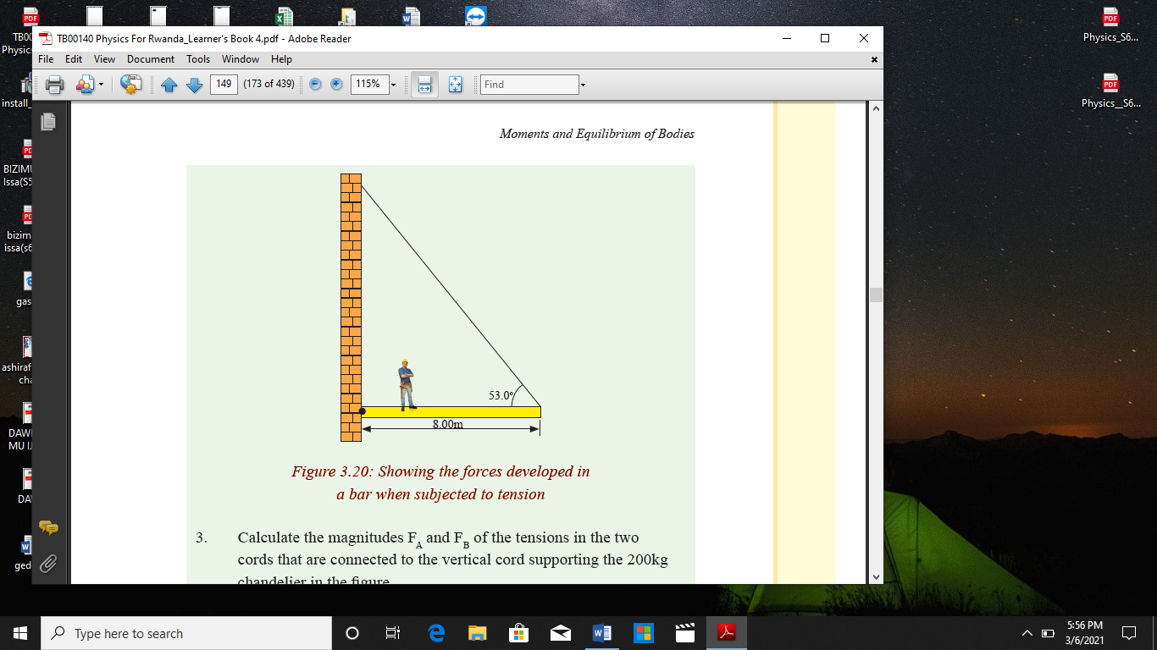

8. a) A person want to use a convex lens as a simple magnifying lens ,at what distance from the lens, must the object be placed and why? **3marks**

b)The power of a magnifying lens is two dioptres. Find its focal length **2marks**

c) An object 1cm taller is placed30mm in front of a lens, an image of the object is located 60mm behind the lens:

i) Is the lens converging or diverging, explain without calculation**2marks**

ii)What is the focal length of the lens**2marks**

d) On the diagram below and the lens is positioned at x=0, using the situation above in (c)

Object

-40 -30-20 -10 0 10 20 30 40 50 60 70 80 90

i. Base on your diagram above describe the image properties. **6marks**

**9. a)** State the principle of conservation of linear momentum for colliding bodies**2marks**

b) State newton’s laws of motion **3marks**

c) Use newton’s law of motion to show that the linear momentum is conserved when two bodies collide**. 7marks**

d) find the momentum of a body of mass 3kg moving at a velocity of 5m/s. **3marks**

**10**. Complete the chart below about the basic types of renewable energy resources. Type Definition Examples Advantages Disadvantages **20marks**

|  |  |  |  |  |
| --- | --- | --- | --- | --- |
| Type | Definition | Examples | Advantages | Disadvantages |
| Solar energy |  |  |  |  |
| Hydropower |  |  |  |  |
| Wind Energy |  |  |  |  |
| Geothermal |  |  |  |  |
| Biomass |  |  |  |  |

11.  **a)** State Kirchhoff’s junctions and loop rules **4pts**

b) Give the sign convention for electromotive force and voltages drops across the resistor in applying loop rule.**4pts**

**c)** Find current I1, I2 and I3 clearly**7pts**

d) Redraw the circuit and show the proper direction of the currents. **4pts**

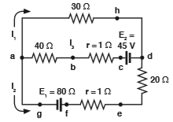

12. The S6Class is investigating the resistance of a wire. The circuit used is shown

below.

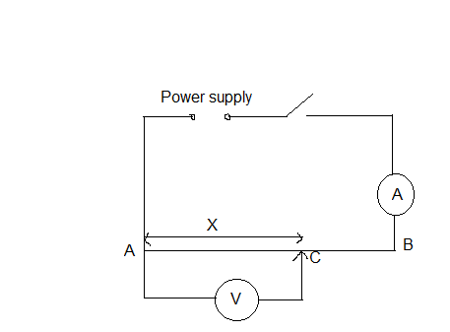

AB is a resistance wire.

The students place the sliding contact C on the resistance wire AB at a distance X=0.100 m from A.

They switch on and measure the potential difference V across the wire AC

They also measure the current I in the wire.The value of I is 0.38 A.

They repeat the procedure several times using different values of X.

The current I is 0.38 A for each value of X.

The readings are shown in the table below

|  |  |  |
| --- | --- | --- |
| X/ | V/ | R/ |
| 0.100 | 0.21 |  |
| 0.300 | 0.59 |  |
| 0.500 | 1.04 |  |
| 0.700 | 1.42 |  |
| 0.900 | 1.87 |  |

a) (i)Complete the column headings in the table **(3marks)**

(ii)Calculate the resistance R of the section AC of the wire for each value of X

**(3 marks)**

b) Plot a graph of R (y-axis) againstX (x-axis).

Draw the best fit line. **(5 marks)**

c) Within the limit of the experimental accuracy, what do you conclude

about the variation of the resistance with distance along the wire?

Explain your answer **(2 marks)**

d) Using your graph, determine the value for R when X=0.750 m.

Show clearly on your graph how you obtained the necessary

information**(3marks)**

e) A variable that may be difficult to control in this experiment is the heating

effect of the current which affect the resistance of the wire.

(i)What will happen to the resistance of the wire if the heating effect of

the current increases?**(2 marks)**

(ii)Suggest how you would minimize the heating effect **(2 marks)**