**BIOLOGY HOLIDAY ACTIVITY FOR S3**

**PART I.**

1. a) Name **one** characteristic feature common to fish, reptiles and birds but not found in mammals. **(1mark)**
2. Glycogen is **(1mark)**
3. a polysaccharide found in animal cells.
4. an energy-storing lipid molecule.
5. a molecule in which plants store sugars.
6. a polysaccharide found in plant cell walls.
7. Animals and plants carry out common life processes like exchanging gases and excretion.

Copy and complete the table to name or describe processes common to all animals and plants.

|  |  |
| --- | --- |
| **Name of the life process** | **Description** |
|  | Living things produce offspring |
|  | Living things get bigger and develop |
|  | Living thing change the position of their body, or part of their body |
| Respiration |  |
| Feeding or nutrition |  |
|  | Detects and respond to changes in the environment. |

**(6 marks)**

1. a)Give a classification of each of the following under the following taxa: **phylum** and **class.**

**i) spider** **ii**) toad **iii)** elephant .

**USE** the table below to answer the question:

|  |  |  |
| --- | --- | --- |
| **ANIMAL** | **PHYLUM** | **CLASS** |
| i) spider |  |  |
| ii)Toad |  |  |
| **iii) Elephant** |  |  |

**b)** state three characteristics that are used to divide the arthropoda phylum into classes. **( 3 marks)**

1. The diagram shows the human breathing system

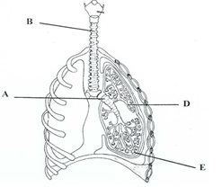

1. Name the parts labelled A, B, C, D, E. /**4 marks**
2. Where do cilia occur in this system? What is their function?/**2** **marks**
3. State precisely the events that take place at E. How is E adapted for these events?/**2marks**
4. Ebola is a viral disease which is spread through direct contact with infected body fluids. For instance blood ,stool, sweat, vomit, urine , semen, or breast milk. Suggest four measures that might limit the spread of this disease. **(4 marks)**
5. a) is an enzyme? **/ 2mark**

b) Describe the characteristics of enzyme. **/ 3 marks**

c) What role is played by enzymes in the germination of maize? **/ 3 mar**

**d)** The reaction below illustrate an enzyme catalyzed reaction

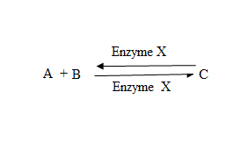 Give any 3 factors that affect the rate of enzyme activity **/3marks**

1. a)Define the terms **transpiration** and **translocat**ion(2 **marks)**

b) Give **any three** reasons explaining why transpiration occurs mainly through the leaves.(3**marks)**

c) Suggest why **translocat**ion is important to the plant(2 **marks)**

d)Explain the mechanism by which water move upward in xylem(3 **marks)**

1. A given food substance is suspected to have proteins.

i)what chemical would you use to confirm the presence of proteins? **( 1mark)**

ii) Describe the procedure you would use and give the expected results. **(3 marks)**

1. Study the following food web.

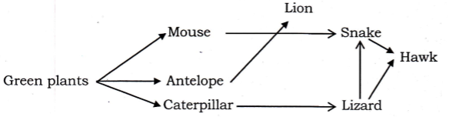

* 1. Give a name of one secondary consumer. **(2 marks)**
  2. What would happen if the lions were attacked by a strange disease and died in large numbers?(**2marks)**

1. The diagram shows the inside of a leaf.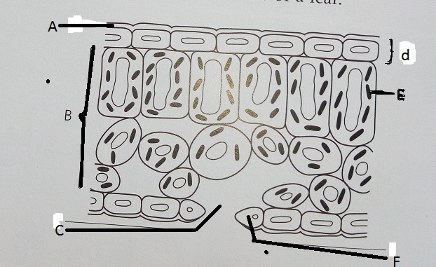
2. list the letters A-F and write the correct label beside each one from the words below.

**Chloroplast, waxy cuticle , guard cell ,leaf tissue , upper epidermis ,stoma.( 3 marks)**

1. copy the list of descriptions and write the correct part from the list above alongside each one.

**Descriptions**:

* + - 1. Cells that make food by photosynthesis. **(1 mark)**
      2. Makes the leaf water proof. **(1mark)**
      3. Hole that lets gases in and out of the leaf.**(1mark)**
      4. Has chlorophyll inside .**(1mark)**

1. Why are leaves able to :
2. absorb lots of light ? **( 1 mark)**
3. get gases to the cells easily?**(1mark)**
4. get water in and sugar out?**(1mark)**
5. An investigation was carried out into the effects of PH on the action of the enzyme amylase on starch. Eight test tubes were set up at different PHS and incubated in water bath at 300 C for one hour. The amount of reducing sugar (product) was estimated. The results are shown in the table below.

|  |  |  |  |  |  |  |  |  |
| --- | --- | --- | --- | --- | --- | --- | --- | --- |
| **pH** | 4.0 | 5.0 | 6.0 | 6.5 | 7.0 | 8.0 | 9.0 | 10.0 |
| **Amount of reducing sugar products** | 1 | 12 | 26 | 32 | 33 | 27 | 13 | 5 |

1. Plot a graph to show these results(3 **marks)**
2. Explain the effect of PH for enzyme in this investigation.(2 **marks)**
3. What is the most suitable PH for enzyme amylase in this investigation?(2 **marks)**
4. Suggest other factors (Not in this investigation) that affect the action of an enzyme such as amylase.(3 **marks)**
5. Define the term transpiration **.(1 mark)**
6. Name three types of transpiration.**( 3 marks)**
7. Explain three environmental factors that affect the rate of transpiration.**(6marks)**
8. Describe the role played by each of the following in human beings:
9. proteins (**2marks)**
10. carbohydrates **(2marks)**
11. lipids **(2 marks)**
12. vitamins **(2 marks)**
13. water **(2marks)**
    * + - 1. **a.**Describe the different types of carbohydrates giving examples of each type.**(6marks)**
14. You are provided with a solution, which is suspected to contain reducing sugar. Describe the possible tests you can carry out to confirm that it is a reducing sugar.**(4marks)**
    * + - 1. a.Describe the different types of carbohydrates giving examples of each type.**(10marks)**

You are provided with a solution, which is suspected to contain reducing sugar. Describe the possible tests you can carry out to confirm that it is a reducing sugar.**(5marks)**

17. a) Write correctly the following scientific names:

i) HomoSAPIENS:

ii) Bos Taurus:

iii) panthera leo **(3marks**)

b) What is the importance of classification of living things? **(3marks)**

18. Draw a line to link the name of the life processes with its meaning.**(4mrks**)

**Life process**  **meaning**

Reproduction •Changing position of a part or all of the body

Growth •Responding to the environment

Movement •Producing fertile offspring

Sensitivity •Getting larger or more developed

19. a) A motorcar can move, take in Oxygen and gives out Carbon dioxide, consumes fuels but nevertheless is not a living organism. In what ways does it not qualify as living thing? **(3marks)**

b) Name the kingdom to which each of the following organism belongs:

i) Grass:

ii) Yeast:

iii) Amoeba:

iv) Vibrio cholerae: (**4marks)**

c) Give two characteristics of the Kingdom Monera (Bacteria). (**2marks)**

20 a) A student wrote the scientific name of blackjack as bidens Pilosa.

i) Identify the mistakes that the student made. **(3marks)**

ii) Identify the genus name for blackjack? **(1mark)**

b) What first aid could you provide to someone bitten by a snake? **(3marks**)

21. Study the table below and answer the questions that follow.

|  |  |  |  |  |  |
| --- | --- | --- | --- | --- | --- |
| **Taxon** | **Human being** | **Lion** | **Wolf** | **Domestic dog** | **Domestic cat** |
| Phylum | Chordata | Chordata | Chordata | Chordata | Chordata |
| Class | Mammalia | Mammalia | Mammalia | Mammalia | Mammalia |
| Order | Primates | Carnivora | Carnivora | Carnivora | Carnivora |
| Family | Hominidae | Felidae | Canidae | Canidae | Felidae |
| Genus | *Homo* | *Felis* | *Canis* | *Canis* | *Felis* |
| Species | *sapiens* | *leo* | *lupus* | *familiaris* | *domestica* |

a) Which organism in the table is **closely** **related** to the domestic cat? Give a reason for your answer. (**3marks)**

b) Which organism in the table is most distantly related to the domestic cat? Give a reason for your answer**. (3marks)**

22. 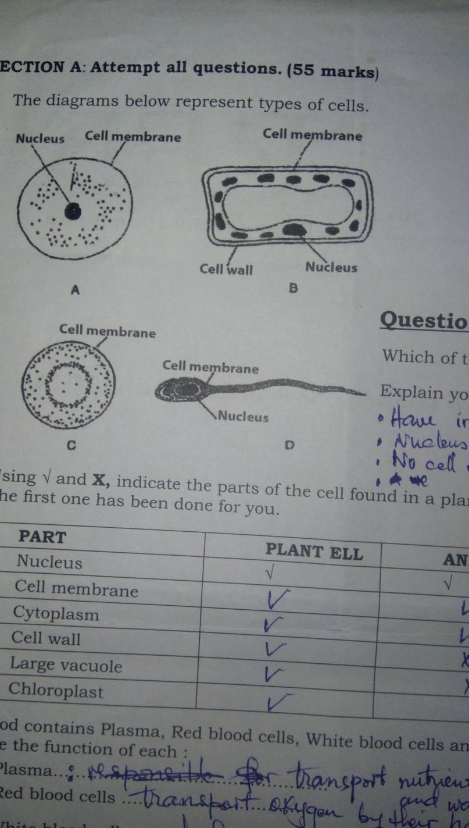The diagrams below represent types of cells.

a) Which diagram: A, B, C or D shows a plant cell? (**1marks**)

b) Explain your answer in (a) above. **(2marks)**

c) Using √ and Ӽ show the parts of the cell found in a plant cell and animal cell. The first one is done for you.

|  |  |  |
| --- | --- | --- |
| **Part** | **Plant cell** | **Animal cell** |
| Nucleus | √ | √ |
| Cell membrane |  |  |
| Cytoplasm |  |  |
| Cell wall |  |  |
| Vacuole |  |  |
| Chloroplast |  |  |

**(5marks)**

23. a) If a nucleus measures 100 mm on a diagram with a magnification of X10 000. What is the actual size of the nucleus? **(3marks)**

b) Kalisa used a microscope to observe a specimen. The eye piece had a magnification of x15 while the objective lens had a magnification of x5. After mounting the specimen, he observed nothing.

i) What went wrong? **(1mark)**

ii) Calculate the magnification of the microscope used. **(2marks)**

24. a) How are red blood cells (RBC) adapted to their role? (**2marks)**

b) Arrange the following structures in increasing order/from smallest to largest:

*leaf, palisade layer, transport system, bean plant, chloroplast, palisade.* ***(3mrks)***

c) The diagram shows a neuron (nerve cell).

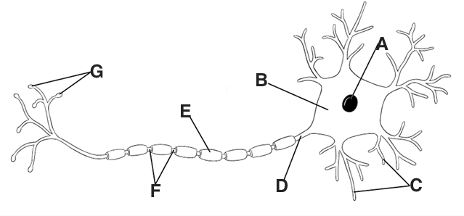

i)Name the structures A, B, C, D, E and F. (**3marks)**

ii) Suggest the function of C. (**2marks)**

25. A team of researchers went to a village near Rubavu and found a five-year-old boy with the following symptoms: **-loss of** **appetite, Irritability, Bleeding gums.**

a) Suggest a disease the boy might be suffering from? (**1marks)**

b) What deficiency caused the disease? **(1marks)**

c) What advice do you think the researchers gave to the parents of the boy? (**2marks)**

d) Write the four uses of proteins in the human body. (**2marks)**

26. a) Which of the sets below consists of respiratory gases only?

i)Oxygen and argon

ii) Oxygen and Carbon dioxide

iii) Hydrogen and argon

iv) Carbon dioxide and hydrogen (**1marks)**

b) Study the diagram and answer to questions related to it.

i) Name the parts labelled 1,3,4,5,6,8, 10 and11. (**4marks)**

ii) What makes part 11 more efficient for gaseous exchange? (**3marks)**

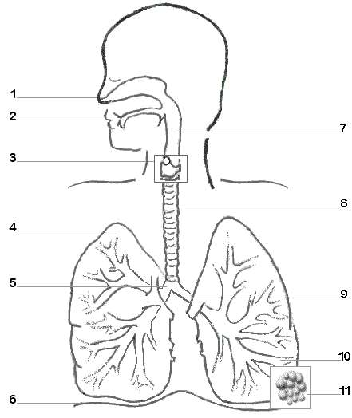

c) Study the model below

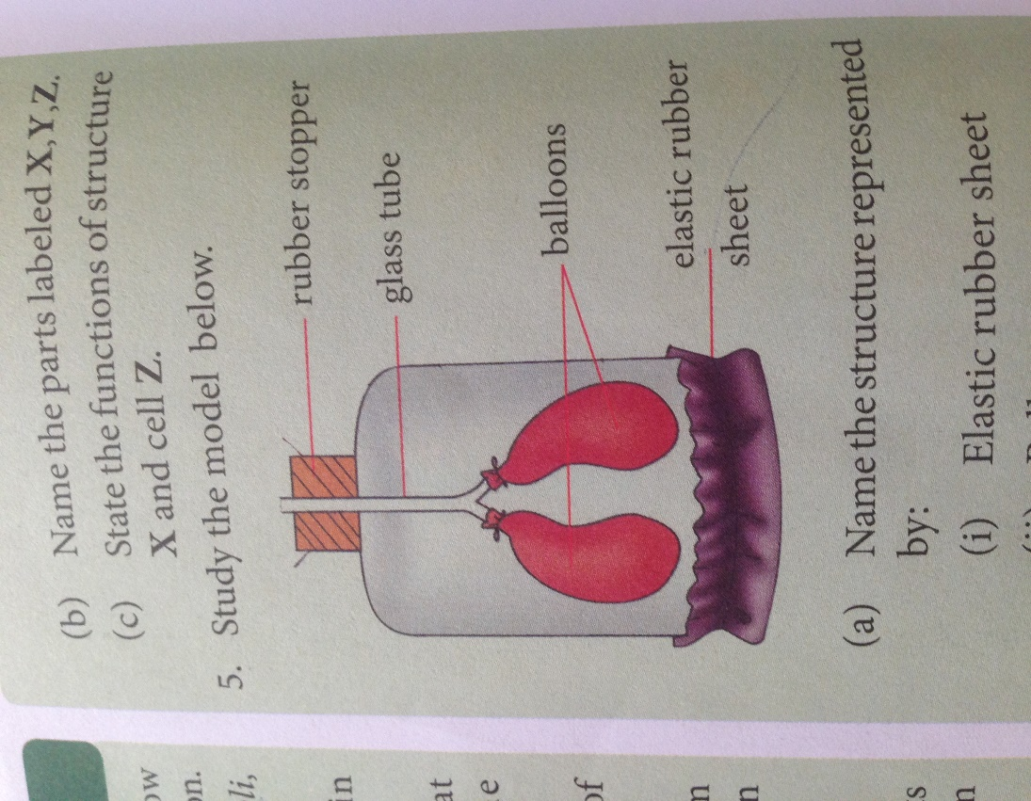

i)Name the structure represented by: a) Elastic rubber sheet

b) Balloons

c) Glass tube (**3marks)**

ii) If the elastic rubber sheet is pulled down, what result you expect to happen? Give reasons. **(2marks)**

27. a) State four reasons why food is important to the body. **(2marks**)

b) Complete the following table.

|  |  |
| --- | --- |
| **Food substance lacking in the diet** | **Deficiency disease** |
| Calcium | ……………………………. |
| …………………………… | Scurvy |
|  | Night blindness |
| B1 | …………………………….. |
| Iodine | ……………………………… |
| Iron | ……………………………… |
| ………………………….. | Pellagra |
| Vitamin D | ………………………………. |

**(4marks)**

28. a) Describe the functions of roots and leaves for the plant. **(4marks)**

b) Give any two types of modified stems and give one example for each. (2mrks)

c) Make a well labeled drawing of a flowering plant. **(4marks)**

29. Malaria is the most disease in Africa.

a. What causes Malaria? **(1mark)**

b. How does it infect people? **(1mark)**

c. Describe all possible means you can recommend to prevent this killer disease. **(8marks)**

Q30. a. Name two foods which are good source of proteins. **(2marks)**

b. Explain briefly why the human body needs proteins. **(2marks)**

c. Describe an experiment you would carry out to tests for proteins in a piece of food. Say what you would expect to see if protein is present. **(3marks)**

d. Human saliva can change at 1% starch solution into maltose solution. Explain why digestive juice from the human stomach would not have this effect. **(3marks)**

Q31. a. How does the increase in size of the human population affect the environment of the earth? **(5marks)**

b. Would an increase in size of the human population of America have the same effect on the environment as an increase in the population of Africa? Explain your answer. **(5marks)**

Q32. a. Name a flying mammal? **(1mark)**

b. A frog is not a reptile. Give two reasons. **(2marks)**

c. What is the difference between *cold-blooded* and *warm-blooded* animls? **(2marks)**

d. A Student says, “Most warm-blooded animals take care of their young. Most cold-blooded animals do not.”

Is this statement correct or not? **(5marks)**

Q33. a. What is meant by the Carbon cycle? (**2marks)**

b. Describe how

(i)the level of carbon dioxide in the atmosphere is maintained. **(5marks)**

( ii) energy flows between organisms during the carbon cycle. **(5marks)**

c. Explain why energy is continually lost along a food chain from a lower trophic level to a higher one. **(3marks)**

Q34. A solution containing starch and glucose was put in a Visking tube in the set up shown in diagram below and left to stand for 30 minutes.

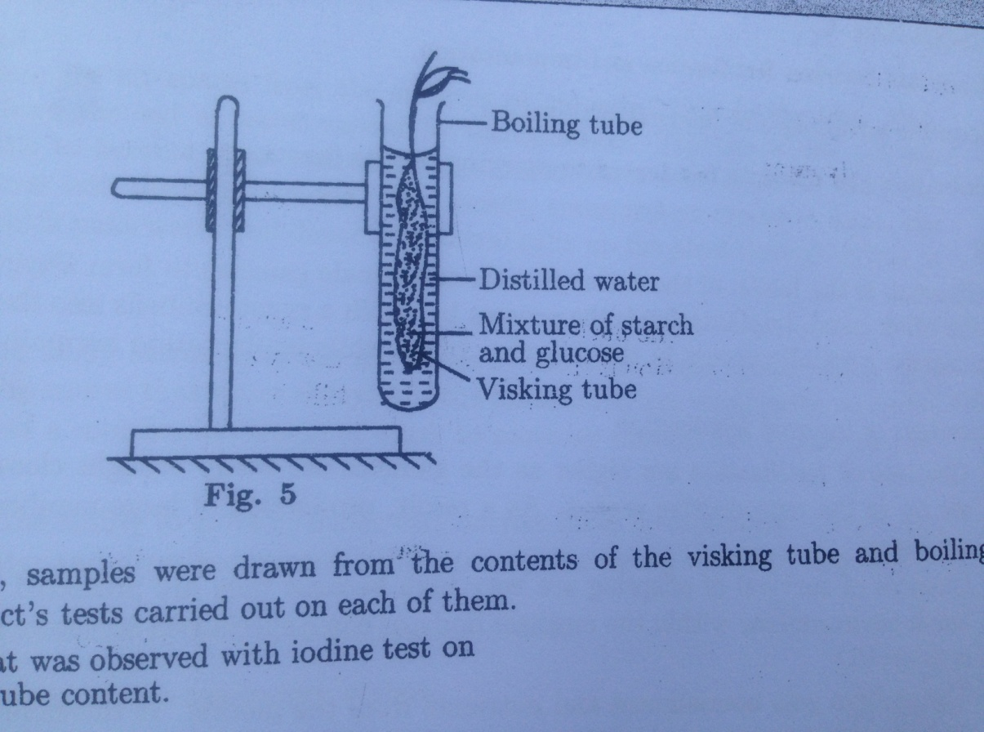

After 30 minutes, samples were drawn from the contents of the visking tube and boiling tube, then iodine and Benedict’s tests carried out on each of them.

(a) Describe what was observed with iodine test on

(i) visking tube content. **(1mark**)

(ii) boiling tube content. **(1mark)**

(b) Explain your observations in (a). **(2marks)**

(c) Describe what was observed with Benedict’s test on

(a) visking tube content. **(1mark**)

(b) boiling tube content. **(1mark)**

(d) Explain your results in (c). **(2marks)**

(e) Giving reasons, state the nature of the visking tube. **(2marks)**

Q35. (a) What is meant by water pollution? **(2marks)**

(b) Outline human activities which cause water pollution. **(4marks)**

(c) How do water pollutants affect living organisms? **(4marks)**

Q36. (a) Name two foods rich in protein. **(2marks)**

(b) What is the final product of protein digestion?  **(1mark)**

(c) Name the extra chemical element which is found in all proteins but not in any other food material. **(1mark)**

(d) What happens to the excessive products of proteins digestion in Mammal’s body? **(2marks)**

(e) Write two uses of proteins in the human body. **(2marks)**

(f)Name the disease caused due to the deficiency of proteins in the diet. **(1mark)**

(g) Write two symptoms of this disease. **(2marks)**

Q37. The diagram below represents an experiment set up by a biologist to demonstrate the effect of stimulus S on the coleoptiles of oat seedlings.

The coleoptiles were treated as follows:

P-Tip untouched

Q-Tip cut off

R-Tip cut off and replaced with agar block X.

(a) (i) Name the stimulus S. **(1mark)**

(ii) Which part of the coleoptiles is affected by stimulus S? Give reasons to support your answer. **(2marks)**

(b) (i) Which substance, in the coleoptiles causes the observed behavior of the seedling? **(2marks)**

(ii) How does stimulus S affect the distribution of this substance? **(1mark)**

(iii) How does the distribution of this substance affect the growth of coleoptiles P? (**2marks)**

(c) Why did coleoptile R respond in the same way as coleoptiles P responded? **(2marks**

(d) Name the type of response exhibited in the above experiment. **(1mark)**

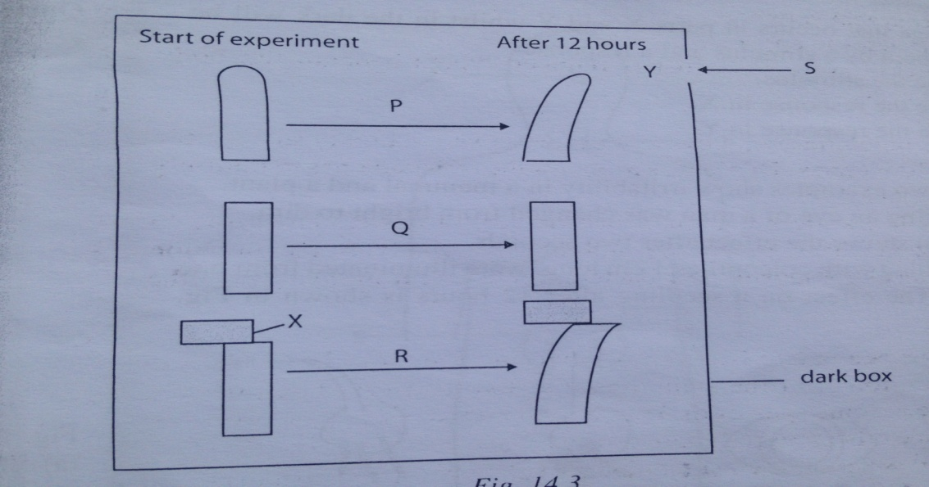

(e) What does the above experiment demonstrate? **(1mark)**

(f) Which of the above seedling P.Q.R can be regarded as control experiment? Give reasons to support your answer. **(2marks)**

(g) In another experiment, the coleoptile tip of the oat seedling was cut off and replaced. The seedling was kept in a dark box with a hole on one side. How did the coleoptiles of the seedling respond to stimulus S? **(1mark)**

-------------END-------------------------