**ES KANOMBE /EFOTEC Class : s3 all classes**

**SUBJECT: Holiday work**

**INSTRUCTIONS**

**1. Attempt all questions**

**SECTION A/ 55 marks**

1.What do you understand by the terms? /4marks

a.Practical geography

b. Tide

2.Show how geography is interrelated with the following subjects: /4marks

i. Geology

ii. Demography

3. State any two characteristics of **equatorial climate**. /2marks

4. Nowadays the world is facing the problem of pollution, whether is water pollution, soil pollution or air pollution.

a. Mention 3 causes of water pollution /3marks

b. Give the effects water pollution /3marks

5. Study the diagram below and answer the questions below

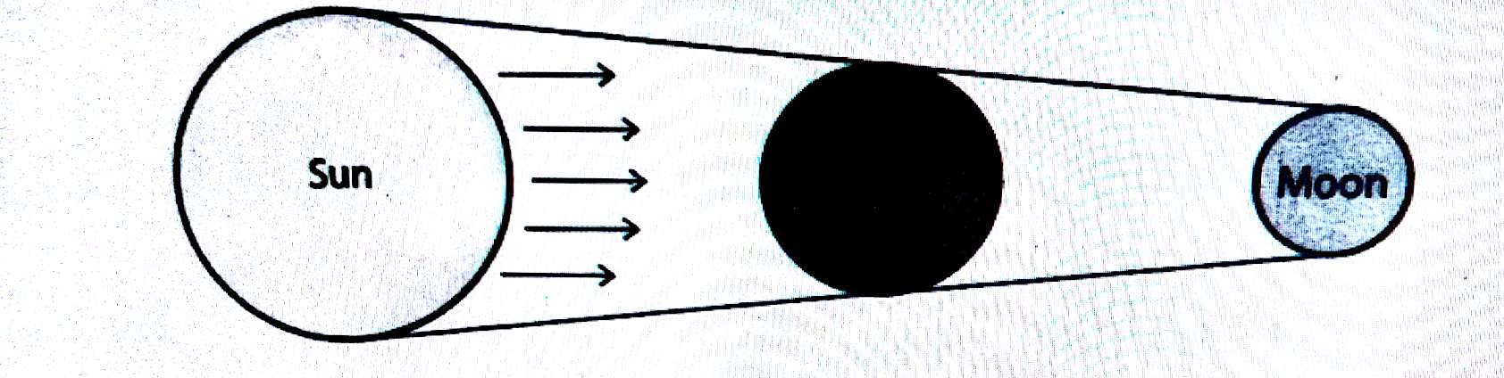

a) What is an eclipse? **(2 marks)**

b) What type of eclipse is shown in the picture above? **(2 marks**

6. Atmosphere is a mixture of various gases surrounding the earth. List any six gases found in atmosphere. /3marks

7. a) Identify any three processes of soil formation **(3 marks)**

b) Describe any two components of the soil **(2 marks**

c) By the help of diagram distinguish between the soil horizons from the surface to the bed rock. /4marks

8. Rural to urban migration is one of the types of migration in Africa and is mostly done by young people. Mention the negatives effects of rural to urban migration. /4marks

9. Study the following diagrams showing an origin of an earthquake and answer

the questions that follow

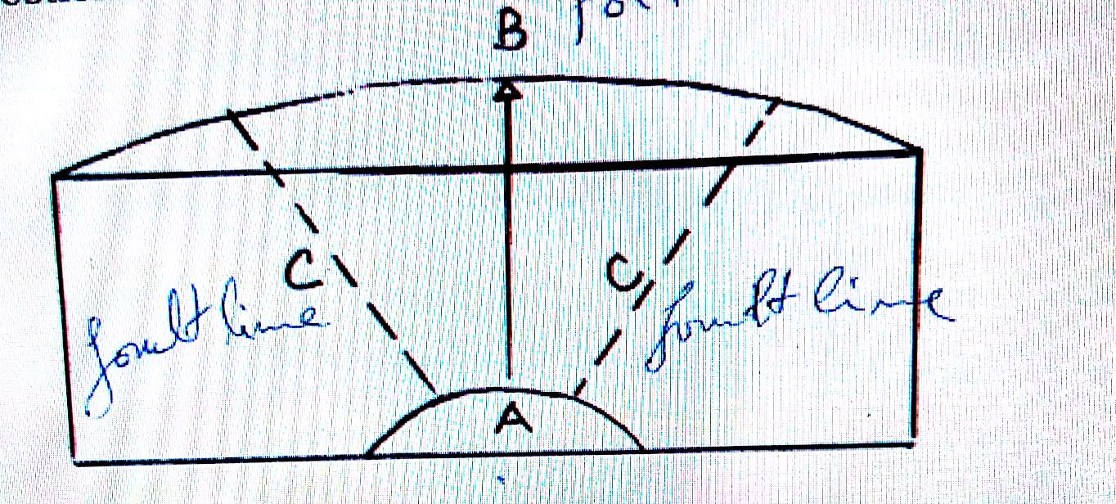

a) Name different parts A, B and C **(3 marks)**

b) Explain any 3 causes of earthquake **(3 marks)**

c) What is the difference between earthquake and tsunami? **(2 marks)**

10. a. Explain how water is a renewable source of energy. /2marks

b. Give three examples of non-renewable energy sources. /3marks

11. Study the diagram below showing highlands of Africa and answer the

questions that follow

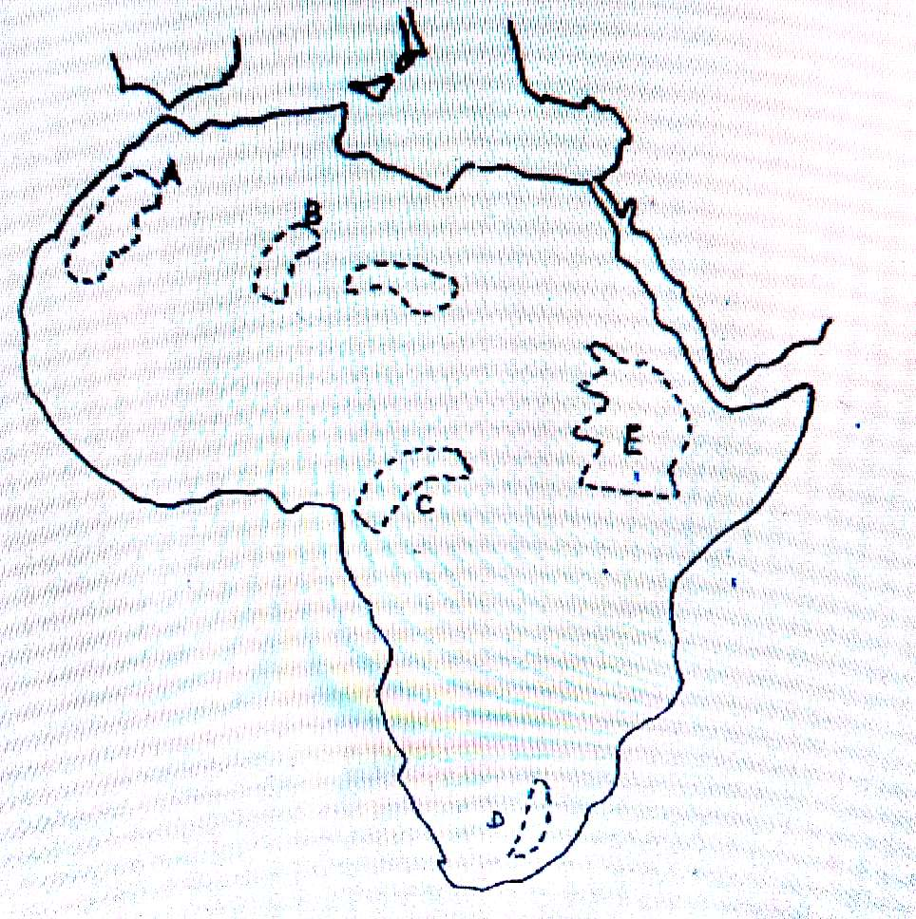

a) Name the highlands marked A, B, C, D and E **(2 marks)**

b) Explain how the highlands marked A were formed **(2 marks)**

12. a. Explain the reasons why environment should be conserved in Rwanda. /3marks

b. Identify the challenges faced in implementation of environmental conservation measures. /2marks

**SECTION B ( attempt any three questions) / 45 marks**

13.a) Briefly by use of sketch, describe any 5 processes of hydrological cycle. /10marks

b) Explain how frontal and orographic rainfall are formed? 5 marks

14. a) Explain the factors that influence land use in a city **(6 marks)**

b) What are the problems associated with urban growth and development

in Rwanda **(5 marks)**

c) What measures is the government of Rwanda taking to overcome the problems

mentioned in (b) above? **(4 marks)**

15.Study the population structure of Rwanda shown in the pyramid below and answer the questions that follow

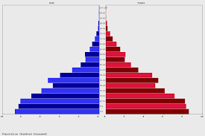

a. Describe the population structure of Rwanda as represented by the above pyramid. /4marks

b. Write brief notes on the causes of high birth rates in Africa. /7 marks

c. Suggest two ways of controlling rapid population growth in Africa. /4marks

16.a. What do you understand by the term “**river basin**”? /2marks

b. Identify any four features formed by a river at its **upper stage/youthful stage** and four features formed at its **old** **stage**. /8marks

c) explain the reasons why most of African rivers are not navigable? 5 marks

17. a) What does dairy farming mean? **(1 marks)**

b) Explain the factors that limit the productivity of pastoral farming in tropical

regions? **(7 marks)**

c) Describe ways that can be used to improve cattle rearing in Rwanda **(7 marks)**

**GOOD LUCKY**