## I.TOPIC AREA: PRACTICAL GEOGRAPHY

## 1. SUB-TOPIC AREA: MAP READING AND PHOTOGRAPHIC INTERPRETATION

***UNIT 1: MAP WORK INTERPRETATION***

**1. INTRODUCTION**

**Map reading:** This refers to the identification, interpretation and analysis of geographical information from maps. A **map** is the representation of any feature or landform on a sheet of paper when viewed from above the ground or surface. A person who draws and produces maps is called a **cartographer.**

**2. IDENTIFICATION OF PHYSICAL AND HUMAN FEATURES ON A MAP.**

**a. Identification of physical features on a map**

**i) Identification of relief features on a map extract**

Relief features (landforms) include plains, plateaus, hills, escapements, ridge, interlocking spurs, valleys, and headlands alternating with bay. These are represented by contours.

**ii) Drainage features**

These include lakes, rivers and swamps, plus any other water body e.g. ocean or sea. On there are defined symbols on the key to represent these features. Note the drainage patterns on the map and how they have affected or how drainage relates to settlements, agriculture, and any other economic or human activities.

**iii) Physiographic features**

Physiographic features include both man made and natural (physical) features

Physiographic = natural or physical (Relief features, Natural lakes & forests, etc.

+Man made (planted forests, roads, railways, boundaries, etc.)

.

**b. Identification of human features and economic activities on a map extract**

* **Mining and quarrying:** this is indicated by the presence of smelting and roasting plants, and quarries whose symbols area defined on the key of the map. Mining sites are good evidences too.
* **Tourism**: this is evidenced by the presence of camping sites, resort beaches, game parks, lodges, hotels, swimming pools, etc.
* **Fishing:** this is evidenced by the presence of landing sites , fisheries departments, canoe landing, ponds, non salty lakes, permanent rivers, fish traps, et.
* **Lumbering:** presence of a forest with a road leading into it, wood workshops, charcoal burning, joinery and construction works, wood factories, etc.
* **Cattle keeping** , dairy farming and animal husbandry: presence of cattle dips, quarantine camps, milk collecting centres, dairy corporation headquarters, veterinary laboratories, cattle markets, pasture lands , etc.
* **Crop farming** and agriculture: coffee factories, ginneries, sugar plantations and jerggery works, maize mills and plantations, tea estates and factories, rubber estates or plantations, etc depict the farming of the respective crops.
* **Trade and commerce**: this is indicated by the presence of trading centres, shops, market centres, etc.
* **Transport and communication**: this is indicated by a network of roads, railways, air fields or strips, ferries, telephone lines, motorboat sites, etc.
* **Manufacturing**: This is depicted by the presence of factories, processing installations, large hydro electric power plants, etc.
* **Settlement patterns**

There are mainly four settlement patterns.

**Linear:** This identified along roads, railways and straight rivers. If huts (always and in dots) are in linear form along these, this is linear settlement.

**Nucleated (clustered)**: This is shown by huts or permanent buildings concentrated in on one area inform of clusters. Trading centers and other areas usually have this kind of settlement

**Scattered (sparse):** This is shown by sparsely distributed huts, scattered randomly away from each other usually in the up country

**Concentric:** This is shown by Circular settlements around a Common center, with defined grids or contours e.g. around a hill as shown below.

**3. RELATIONSHIP BETWEEN PHYSICAL AND HUMAN FEATURES ON THE MAP**

**i) Relating relief and the various economic and human activities on a map extract**

Note: Relief can be described in 3 forms. These include:

**-**Steep (hilly) Relief; This may also include mountainous relief eg: mountains, escarpments, ridges and other forms of highland.

-Flat relief.

-Valley relief such as depressions and other forms of lowland.

On the other hand Economic and Human activities that can be related with relief include: Settlement, communication, farming, animal rearing (Grazing), quarrying, mining, transport, tourism etc.

Thus when asked to relate relief with any of the Human or Economic activities, you are required to show the examiner how relief in its various forms has influenced or affected the Human activity in question. Note that influence can be positive or negative;

**Influence of Relief on Settlement: (i.e. relating Relief and Settlement):**

Steeply hilly relief tends to influence settlement negatively by discouraging effective construction of houses on the steep slopes. On the other hand, flat relief tends to influence settlement positively by encouraging effective and easy construction of houses. Valleys are not normally settled because they tend to be swampy.

* **Relating Relief and Communication and Transport**:

It should be noted that transport and communication includes railway and road networks, and communication lines such as telephone lines on map extracts. Therefore relief affects the above networks in the following ways:

Steep and hilly relief filled with ridges/sharp scarps tends to discourage easy construction of road and railway networks.

On the other hand, flat relief tends to influence transport and communication positively hence encouraging it. This is because the flat nature of relief makes it easy for construction machinery to move and there are no galleys, making the roads long lasting. Even valleys also, transport and communication networks are not easily constructed.

* **Relating Relief with other Human Activities:**

**Steep relief** tends to be more useful for rock quarrying while it discourages grazing since most steep slopes are without vegetation but with only exposed hard rocks.

Some steep relief and mountains encourage tourism because of their impressive appearances in most cases.

**Mining** as related to relief is more easily carried out in valley relief and flat land. This is because minerals are normally found below the surface and thus valleys are much more nearer to the mineral than if mining was started at mountain tops.

In most valleys, clay mining tends to be dominant .Also valleys can be used to grow particular crops that thrive in water logged areas such as rice, yams.

**Animal rearing** and other activities tend to be encouraged more on flat and than steep relief.

In conclusion therefore the reader should first observe the map extract and the human or economic activities taking place on the map, (note the symbols for each activity as already discussed) and then look at the contours to identify the nature of relief on the map.

This will help to identify what activity is carried out on the various types of relief shown on the map extract.

* **Relating Relief and Drainage:**

Relief influences drainage both positively and negatively in the following ways:

-Hill or steep relief has encouraged the development of radial drainage

-Faulted relief in rectangular form has led to the development of trellis drainage

-Undulating relief in rectangular form has led to the development of trellis drainage

-Valley relief has also encouraged swampy drainage with springs and valley guided rivers.

-Warped nature of relief such as down warped depressions has led to the development of down warped lakes.

-Centripetal drainage has also developed as rivers converge in a central depression due to the valley nature of relief.

-Up warped and down warped relief has also led to development of hooked drainage as rivers change direction, causing their tributaries to join the main stream in opposite direction.

-Relief with escarpments tends to form parallel fault guided valleys which lead to development of parallel drainage of rivers.

**Relating drainage and the various human and economic activities on a map extract**

Note:

-Drainage system includes the whole network of rivers, lakes, canals, swamps and any other water distribution on the surface of the earth.

-Thus, a student of geography and any geographer should show how the presence or absence of the above drainage features in any given map extract has influenced (i.e. encouraged or discouraged) the various human or economic activities that may be carried out on the map extract.

-Water bodies encourage agriculture.

-Also the rainfall encourages vegetation and this attracts population to settle near and or around these water bodies in order to carry out their activities.

-No construction of settlements can be possible in the water.

-Also water bodies are sources of water for domestic and industrial use.

-On the other hand, absence of drainage features in an area tends to attract less or no settlement at all.

**Relative Drainage and Communication and Transport**:

Presence of large and deep drainage features like lakes and rivers tend to encourage water transport by use of ships, ferries and boats.

However, water bodies tend to discourage road and railway transport and communication lines such as telephone poles.

**Relative Drainage and Other Human/ Economic Activities:**

The presence of drainage features tends to encourage most human activities such as farming due to reliable rainfall, fishing on fresh water bodies etc. On the other hand, absence of drainage features in any area tends to cause aridity in the affected areas especially if other factors are constant.

**4. DRAW SKETCH MAP**

Sketching map does not include drawing the map itself. It focuses on the identification, marking using symbols and labeling the marked features in their relative position and should reflect proportionality of the sizes of features.(eg: do not draw small river to occupy the whole sketch).

**Procedure of drawing sketch map** -Measure the dimensions of map and transfer it to draw a frame on the answer sheet

NB: Large map may be reduced proportionally whose shape is similar to that of photograph

-Study the features in question and identify their location

-After sketching the map, mark and label the features in question, key is also used

-The sketch must have, a title(heading) in relation to the question. The title outlines what the sketch represents.

NB: Avoid unnecessary shading and including details that are not required by the question. Avoid congesting the sketch with too many labels and features.P72MKS6.

5. REDUCTION AND ENLARGEMENT OF MAP

**a. REDUCTION OF MAP**

In some cases the map may be small.

**The steps used to reduce map**

-Measure the dimension, length and width

-Using a given scale factors for eg.(11/2,21/2) the dimensions by dividing the dimensions

-Produce an outline map that has new dimension (length and width)

-Mark and label the features in question in their relative positions

-Label the features using specific names

Eg: The photograph is 12cm by 16cm in dimension. You are required to reduce it by the scale

factors if 11/2.NB:You have to establish the dimension through measuring its width and length when it is not given.1.for the width and length divide by 11/2

Width=12:3/2 =12x2/3=8cm Length:16:3/2 =16x2/3=10.6cm P100-101 MK S6

**b. ENLARGEMENT OF MAP**

When asked to enlarge a map, the following steps should be taken; one has to produce a sketch

that has bigger size.

-Measure the dimension of map, multiply the width and length of map by scale factors

-Using a given scale factor, draw a frame of the map using the new dimensions

-Mark and label the features in the relative positions using their specific names

-Add marginal information that is applicable. P101-103 MK S6

NB: Sometimes the scale factors may be given in terms of percentage eg:85%

Eg: 1)13cm by 9.6cm as dimensions of map, we are required to enlarge the map by 85%

Length:13cm=13:85/100=13x100/85=15.3cm Width:9.6cm=9.6:85/100=9.6x100/85=11.3cm

2) Enlarge the map by a scale factor of 11/2 thus

Length=10cm width=8cm

**Length=10cmx11/2=10x3/2=15cm Width=8cmx11/2=8x3/2=12cm**

Task p104-105 MK S6

## II.TOPIC AREA: PHYSICAL GEOGRAPHY

## 2.SUB-TOPIC AREA: RELIEF

***UNIT 2: RELIEF IN AFRICA AND THE WORLD***

## 1. INTRODUCTION TO AFRICA

## 1. Location: Africa occupies a more or less central position of the world between Central and South America to the West Australia and South/South West Asia to the East, Europe to the North and Antarctica to the South. The continent is surrounded by large expanses of water. To the West is the Atlantic Ocean, to the North is the Mediterranean Sea, and to the east is the Indian Ocean while the Red sea and Suez Canal are found in the Northeast. Latitude:340 S at Cape Agulhas in RSA and 370N at Tunis in Tunisia, Longitude 170W at Dakar and 510E at Cape Guardafui in Somalia.

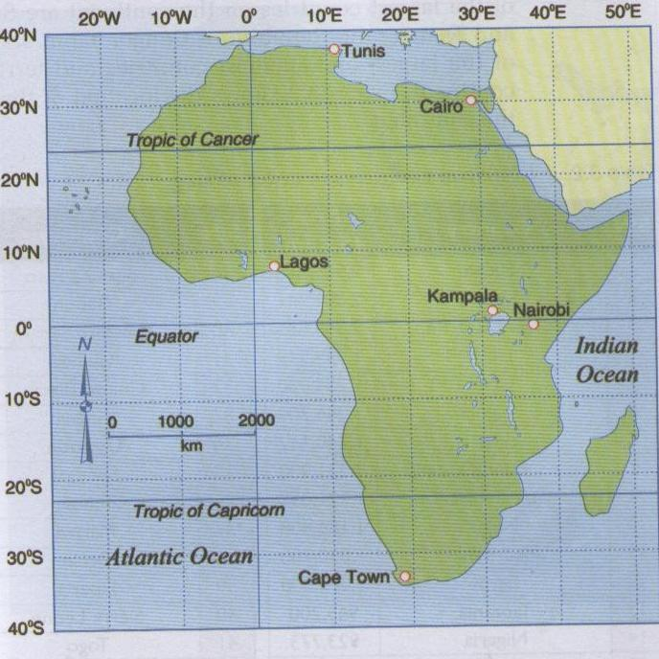

**Fig. The location of Africa**

### 2. Size: Covering an area of about 30,335,000 km2, Africa is the second largest continent after Asia. The Equator almost divided Africa in half, the northern half extends for about 3800km while the southern half extends for about 4100km southwards from the Equator.

### Africa’s size in comparison with other continents

|  |  |
| --- | --- |
| Continent | Size (square km) |
| Asia | 43,608,000 |
| Africa | 30,335,000 |
| North America | 25,349,000 |
| South America | 17,611,000 |
| Antarctica | 11,400,000 |
| Europe | 10,498,000 |
| Oceania | 9,037,695 |

### 3. Shape: The continent has an uneven shape, the northern half is wide spreading out westwards as west Africa and eastwards as the horn of Africa in the Somalia area. In contrast the continent is comparatively thinner and narrower south of the Equator.

### 4. Population: Africa is the second most populous continent after Asia and it accounts for about 14.8% of the world human population that is a billion people (1,000,000,000) in 2009, (1,033,000,000) in 2013.

### 5. Political geography of Africa

Africa consists of 55 countries, Territories (Western Sahara) and islands like Madagascar, Comoros, Zanzibar, Pemba... These countries exist in various countries areas.

**African countries in order of size**

|  |  |  |  |  |  |  |
| --- | --- | --- | --- | --- | --- | --- |
| **No** | **Country** | **Area(Sq.Km)** |  | **No** | **Country** | **Area(Sq.Km)** |
| 1 | Algeria | 2,381,741 |  | 29 | Burkina Faso | 274,122 |
| 2 | Congo Dem. Rep. | 2,344,885 |  | 30 | Gabon | 267,667 |
| 3 | Sudan | 1,886,068 |  | 31 | Western Sahara | 252,120 |
| 4 | Libya | 1,759,549 |  | 32 | Guinea | 245,857 |
| 5 | Chad | 1,284,000 |  | 33 | Guinea Bissau | 245,857 |
| 6 | Angola | 1,246,700 |  | 34 | Ghana | 238,305 |
| 7 | Mali | 1,240,142 |  | 35 | Uganda | 236,000 |
| 8 | Ethiopia | 1,221,900 |  | 36 | Senegal | 196,192 |
| 9 | South Africa | 1,221,037 |  | 37 | Tunisia | 164,150 |
| 10 | Niger | 1,186,408 |  | 38 | Malawi | 118,484 |
| 11 | Mauritania | 1,030,700 |  | 39 | Benin | 112,622 |
| 12 | Egypt | 1,002,000 |  | 40 | Liberia | 112,600 |
| 13 | Tanzania | 945,200 |  | 41 | Sierra Leone | 73,326 |
| 14 | Nigeria | 923,773 |  | 42 | Togo | 56,785 |
| 15 | Namibia | 824,269 |  | 43 | Lesotho | 30,355 |
| 16 | Mozambique | 799,380 |  | 44 | Equatorial Guinea | 28,051 |
| 17 | Zambia | 752,614 |  | 45 | Burundi | 27,834 |
| 18 | Somalia | 637,657 |  | 46 | Rwanda | 26,338 |
| 19 | Central African Republic | 622,436 |  | 47 | Djibouti | 23,000 |
| 20 | Republic of South Sudan | 619,745 |  | 48 | Swaziland | 17,400 |
| 21 | Madagascar | 587,041 |  | 49 | Gambia | 10,689 |
| 22 | Kenya | 582,600 |  | 50 | Cape Verde Is. | 4,000 |
| 23 | Botswana | 582,000 |  | 51 | Reunion | 3,000 |
| 24 | Cameroon | 465,054 |  | 52 | Mauritius | 2,040 |
| 25 | Morocco | 458,730 |  | 53 | Comoros | 1,862 |
| 26 | Zimbabwe | 390,308 |  | 54 | Sao Tome and Principle | 1,000 |
| 27 | Congo | 342,000 |  | 55 | Seychelles | 444 |
| 28 | Cote d'Ivoire | 322,463 |  |  |  |  |

The largest country in Africa is Algeria with 2,381,741km2 while the smallest country is Seychelles with 444.

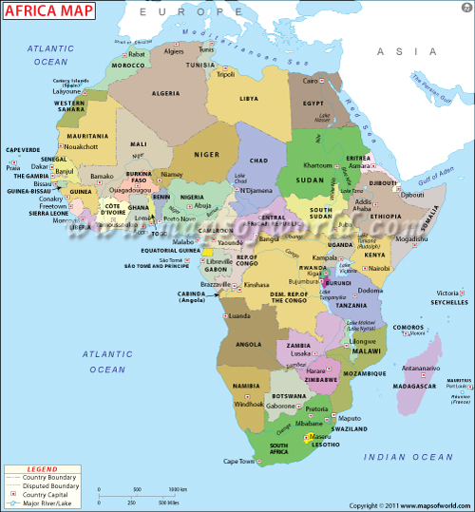

**Fig 3.2 Political divisions of Africa**

## 2 . MAJOR RELIEF FORMS OF AFRICA

### 1. Relief

Relief is the physical landscape of the surface of an area .It is therefore the physical appearance and set up land surface in any given area .The continent consists of very old basement rocks that have experienced changes over millions of years. The plateau is highest in eastern Africa gradually sloping down to the west. The plateau is gradually interrupted by other relief features and landforms. These includes the mountains of Drakensberg and Cape ranges in the Republic of South Africa, Kilimanjalo (the highest point in the whole Africa with 5895m of altitude located in Tanzania), Kenya and Rwenzori of East Africa; the Adamawa of Cameroon; the Ethiopian highlands of Ethiopia as well as the Ahaggar, Tibesti and Atlas mountains of North Africa. There are basins in between the highlands. Examples are the Okavango, Congo, Chad, Nile and El Djouf basins.

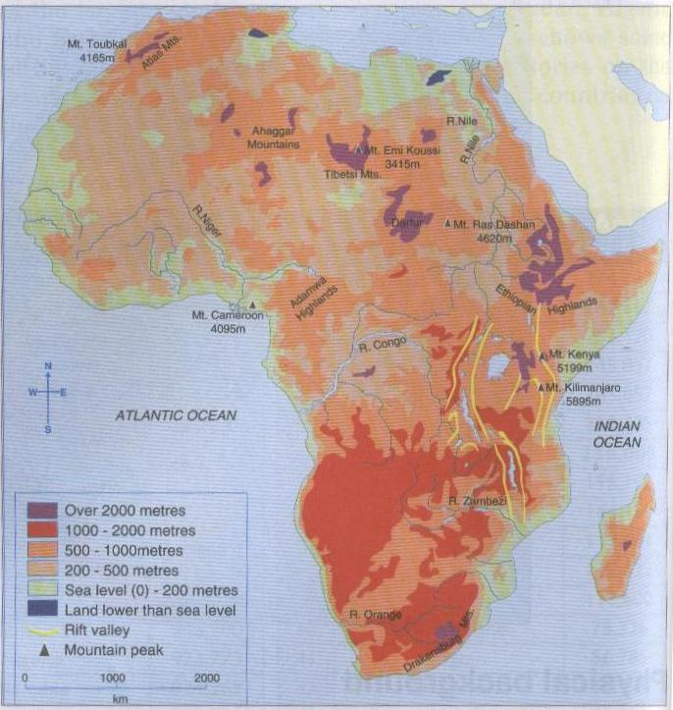

**Fig 3.3 The major relief features of Africa**

### 3. MAJOR RELIEF FORMS OF OTHER CONTINENTS

### A.EUROPE

Major relief fractures

* Plains: located in the North and vast in East: Great European plain
* Plateaus: central uplands like massif central of France and central Russian uplands
* Mountains: southern like Alps (Switzerland), Pyrenees (Spain), Carpathians (Ukraine), Apennines (Italy), the Dunaric Alps and the Balkans, volcanic mountains (Mount Vesuvius (Italy) and Mount Etna (Sicily islands).

B.AMERICA

* + - 1. **Relief of America**

North America is geographically divided into eight relief which include the following:

**The Rocky Mountains**: high Mountains, formed during Alpine or tertiary period (40 million years ago). Folded mountain ranges and some are hard raised edges of faulted blocks. These rocks are rich in many minerals. They are permanently covered by snow and are being eroded by the melting snow. They stretch from Alaska to the south in New Mexico and extend southwards into Mexico forming the Sierra Madre Oriental Maintains. They are covered by very wide forests. These Rockies attract many tourists from a whole World.

**The Eastern Coastal Plains (Lowlands):** these are flat coastal plains sometimes called “Lowlands”. They stretch along the Atlantic coast and the Gulf of Mexico from New York City to Mexico’s Yucatan peninsula. They have fertile soils which have encouraged farming resulting in good farm lands.

**The Western Plateaus and Basins**: There are situated between the pacific ranges and the Rocky Mountains. This region is made up of Yukon River basin in Alaska and Canada, the interior plateau of British Columbia and the Colorado plateau of Mexico. It is in this region of North America that much of the copper, gold, lead, silver and zinc are mined. Their significant landscapes include the Spectacular Grand Canyon that is to say a very deep gorge. It is California that the Lowest part commonly known as the DEATH VALLEY is found. This valley lies approximately 86m below sea level.

**The Canadian Shield**: The Canadian Shield is large area of ancient rocks composed of worn out plains of igneous and metamorphic rocks. It covers the eastern half of Canada, Greenland, Minnesota, Wisconsin, Michigan and New York. This area has the poor soils and cold climate. It is well known for its mineral potential. Every green forests spread-across the southern part of this region.

**The Interior plains**: The interior plains generally cover much of central Canada and the mid-western parts of the US. The Eastern part of this low lying region is North America’s most productive of CORN and HOGS. The great peaks in the western parts, which are generally dry, supply most of the continent’s WHEAT, CATTLE, PETROLEUM and NATURALGAS.

**The Appalachian Highlands**: The Appalachian Mountains extend from the new found land to the state of Alabama. This region is occupied by low rounded mountains, plateaus, and valleys. It is here in Pennsylvania that one of the World’s largest productive coal fields lie in the Alleghany plateau and in the central part of the region. Hard wood forests have grown luxuriantly in the southern and the northern parts of this region.

**The Western ranges and lowlands on the pacific coast**: This relief region comprises two parallel mountain ranges demarcated by series of valleys. The mountain ranges begin in Alaska and run southward as far as Mexico. In between these mountain ranges lie fertile valleys which are agriculturally productive. Other mountain ranges include the Coastal Mountains of Oregon and California as well as the Olympic mountains.

**The Caribbean and Central American ridge:** Narrow ridge of land at the southern tip of North America and the Caribbean Islands. A Chain of Volcanoes forms a mountain system along the Pacific coast of Central America. Most of the Caribbean mountains are as a result of Vulcan city. Others were formed as a result of coastal deposition of coral and limestone formations. The one highest mountain is Mac Kinley; one of North America’s highest, 6,194m above sea level in the mountain ranges of Alaska.

**Major relief of South America**

**The Andes**: They are the World’s longest exposed mountain ranges. They lie as a continuous chain of highlands along the western coast of South America. The range is over 7,000km, long 200-700km wide (widest between 18° to 20°S latitude), and of an average height of about 4,000m. The Andean range is composed principally of two great ranges, the Cordillera Oriental and the Cordillera Occidental often separated by a deep intermediate depression. Cordillera Oriental is from the Spanish language meaning “Eastern range” whereas Cordillera Occidental means “Western Mountain”. The Andes can be divided into 3 sections: The southern Andes in Chile and Argentina, Central Andes (The Chilean and Peruvian Cordilleras and parts of Bolivia), and the Northern section in Venezuela, Colombia and Northern Ecuador consisting of two ranges: the Cordillera Occidental and the Cordillera Oriental.

**The central lowland**: These lie east of the Andes. They are large lowlands drained by a small number of rivers including the two largest in the World AMAZON River and the more Southerly Parana River. Others are the ORINOCO River which has a natural channel linking it with Amazon. Most of this central lowland is sparsely populated because the soils are heavily leached, but in the south is the very fertile pampas of Argentina-One of the World’s major food-production regions where wheat and beef cattle are pre-eminent. The natural vegetation of the northern lowland is either savannah in the northern lowlands is either savannah in the northern Manos and Southern Compos, or tropical rainforest throughout most of the Amazon basin.

**The Guiana Shield:**  The Guiana shield is one of the three Cratons of the South American plate. A Craton is an old and stable part of the continental crust that has survived the merging and splitting of continents. The Guiana Highlands are the source of some of the World’s most spectacular Waterfalls ANGEL FALLS, KAIETEUR FALLS and KUQUENAN FALLS

**The Coastal Plains:** A coastal plan is an area of flat, low lying land adjacent to a seacoast and separated from the interior by other features. South America’s coastal plain is one of the World’s longest coastal plains.

**C.ASIA**

**Relief of Asia**

There are 3 major relief divisions:

* The Northern Lowlands made up of the Siberian Plain and the Turan Plains
* The Central Mountain Belta complex system of Fold Mountains and plateaus. Some of the major mountain ranges are the Himalayas, the Kunluns, the Hindukush, the Zagros, and Pontic ranges. The plateaus of Tibet, Iran, and Mongolia are some of the inter-montane plateaus.
* The Southern Plateaus are made up of old, hard, crystalline rocks namely; the plateaus of Arabia, the Deccan, the Shan, and Yunnan plateau.

**D.OCEANIA**

The islands of the Pacific are often classified according to their altitudes as high or low islands.

|  |  |  |  |  |
| --- | --- | --- | --- | --- |
|  |  |  | Types of Islands: High Islands | |
|  |  | | |  | |

High islands are further classified as either continental or oceanic. The continental high islands were once part of the eastern edge of the Australian and Asian continents and are composed of substances similar to their former continents: ancient metamorphic rocks and sediments as well as rocks such as schist, gneiss, clay, and sandstone. Continental islands include New Guinea and most islands of Melanesia, which together account for more than three-fourths of Oceania’s land area.

The oceanic high islands, sometimes called volcanic islands, are divided from the continental high islands by a north-south boundary of rock formations beneath the sea called the Andesite line. The oceanic islands are composed of volcanic materials that were forced upward through cracks, or fissures, in the ocean floor and from newly deposited sediments. The islands, then, are merely the tops of undersea mountains. Typically, the mountains (and thus the islands) extend in curving chains. These high oceanic islands are common in Polynesia and Micronesia. The island of Hawaii, in Polynesia, contains the peaks Mauna Loa and Mauna Kea, which are considered the world’s largest mountains in terms of mass and height above the ocean floor.

|  |  |
| --- | --- |
|  | Types of Islands: Low Islands |

Like the high islands, low islands are also further classified into two subgroups: eroded volcanic islands and atolls. The eroded volcanic islands are much like the oceanic, or volcanic, high islands, only they have been eroded to such a point that they are barely above sea level. Examples of these islands include the smaller, lower islands of Hawaii.

**Atolls** are a series of islands that form a rough ring enclosing a central body of water called a **lagoon**. The various islets of the ring are called *motus* and are separated by sea channels that lead into the lagoon. An atoll is continually built upward from an underlying coral reef, itself formed from the skeleton of a tiny, lime-secreting animal called a polyp.

The larger islands, typically continental and oceanic islands, have narrow coastal plains with spectacular volcanic mountains and plateaus rising abruptly from the coast. The highest of these are in New Guinea, Hawaii, and New Zealand. Although New Guinea lies just south of the equator, it has snowcapped peaks. The highest peak is Puncak Jaya in Indonesia’s province of Papua, at 5,030 m. New Zealand’s North and South islands have more than 200 mountains higher than 2300 m. Rivers on these larger islands flow rapidly from the rugged mountain interiors to the sea, carrying sediments that form large river basins and deltas. The basins and deltas are fertile farmlands that can play an important role in the island’s economy. Such rivers include the Fly in Papua New Guinea and the Rewa and Sigatoka on Fiji’s Viti Levu Island. By contrast, coral atolls have no rivers.

## 3.SUB-TOPIC AREA: ROCKS, WEATHERING AND SOILS

***UNIT 3: SOILS IN AFRICA AND THE WORLD***

1. **Introduction:**The soil is defined as the top material on the surface of the earth in which most of the plants roots grow. It is composed of both inorganic and organic matter. Inorganic particles are derived from the breakup of rocks. The organic materials consist of decaying plants and animals.

**Soil composition and element in the soil**

-Soil air -Soil water and moisture -Living organism -Soil particles of various sizes

-Inorganic materials -Organic materials

### Major type of Soils of Africa

There is a great variation in the soils of the continent. The soil types include:

+ Lateritic soil of the old pre-Cambrian surface

+Saline (salty) soils of the coastal region

+Highly leached soils (latosols) in Equatorial climatic zones

+Sandy rock debris desert soils

+The soils of volcanic origin in the highly vulcanized areas of Eastern Africa and parts of West Africa

+Alluvial soils along river valleys and in deltas at river mouths

+Moraine soils in glaciated mountainous regions

### 3. Factors for soil formation

**a. Parent rock**: as some rocks are hard while others are soft, they respond to weathering processes at different rates. Normally, the softer the parent rock, the faster the rate of soil formation and vice-versa (the harder the parent rock, the slower the rate of soil formation).

**b. Climate**: high temperature and heavy rainfall increase the rate of rock decomposition and therefore the rate of soil formation. In arid and semi arid environments, the expansion of rocks during period of high temperature and their contraction during periods of low temperature cause cracks of rocks in place (physical weathering) and produce particles that become soil particles.

**c. Living organisms**: living organisms change the nature of the parent rock. Animals for example contribute to the decomposition of hard rocks and complex minerals into simple substances. The roots of plants usually disintegrate rocks and therefore contribute to the production of particles necessary for soil formation, bacteria decompose vegetation into humus.

**d. Relief**: there is a higher rate of soil formation on steep slopes compared to gentle ones. Also, soil removal from the surface is faster on steep slopes compared to gentle ones.

**e. Time**: the longer a rock is exposed to processes of soil formation, the more developed the soil. Recently formed rocks have immature soil compared to rocks made long ago.

### 4.Major type of soils in other continents

### a. EUROPE b.AMERICA C.ASIA

Asia’s soils are related mainly to climate and vegetation. In some areas the origins of soils, perhaps from volcanic action or from materials carried by streams, may be more important. Such volcanic or alluvial soils are especially fertile.

The tundra soils of the northernmost part of the continent are acidic and infertile. Many of these areas are underlain by permanently frozen subsoils that never thaw during the brief summers. Subsoils of this type, known as permafrost, cover a very large area in the northern part of Siberia.

South of the tundra, the soils of the taiga are also acidic and relatively infertile. Somewhat less acidic and more fertile soils are found in the mixed forests and the broadleaf forests farther south.

Prairie and black chernozem soils are south of the forests. Because these soils developed where there is limited precipitation, their desirable minerals have not been absorbed or washed away, a process known as leaching. These soils are among the most fertile in the world. The best farmland of Russian Asia occurs largely on black soils and on the more inferior soils of the mixed and broadleaf forests.

The unleached soils of the semiarid and arid areas of the continent are often fertile, except where they are too saturated with salts or alkaline minerals. The availability of water for irrigation largely determines their use.

The soils of the rainy tropics are generally infertile. High precipitation and high temperatures cause most of the valuable minerals to be leached from the soil.

Many of the red and yellow soils of the humid subtropical area of China have been improved by thousands of years of care, which has included the use of compost, or rotted plant refuse. In some semiarid regions of China, however, natural vegetation with deep roots

### d.OCEANIA

Soils on coral atolls are thin, sandy, and much less fertile. Sparse vegetation consists of shrubs, small trees, grasses, and the very common coconut palm. However, on low islands that receive heavier rainfall, some forests exist. As with other islands, mangroves and other salt-tolerant plants line the coasts of atolls.

### Relationship between soil type and human activities

Soils influence the economic activities carried out in various parts of the continent. The nature and type of soil influences or discourages the practice of certain economic activities:

* Laterite soils derived from laterite rock do not contain sufficient nutrients that can sustain plant life. These soils are poor. Where they occur, **crop cultivation is difficult and sometimes impossible.** However, the soil may influence the **growth of short stunted** grass. Some domestic animals such as sheep and goats may feed on such grass thus contributing to the activity of **livestock farming**. Soils with high clay content are often utilized in clay works. The clay is extracted and used in industries such as **pottery and brick-making**. Clay soils enable the growth of **hydrophytes** (water-tolerant crops). The infiltration rate through clay soil is low. Clay soils are favorable for plants such as **yams and sugarcane.**
* Alluvial soils contain a variety of nutrients and are quite fertile. They support human activity of **cultivation.** In Africa, the **Nile floods plain, the Niger Delta** and several river valleys containing alluvium are associated with **successful agriculture**.
* Sandy soils are sometimes quarried and utilized as constructional aggregates (construction). Example: shore of Lakes and bank of rivers.
* Beauxite soils (laterite soil with a high aluminium content) support aluminium mining.

**Importance of soil**

1. Soil is significant to animals in that it supports plant lifes (food,habitat)

2. Soil is eaten directly by animals in the form of salt licks

3. Soil is one of the most important resources to people where plant grow/food to people/building materials/timber/fuel (woods) and medical herbs.

4. Soil is used in making brick, tiles, 5.Soil is used in pottery,ceramics,sculptures

6. Some soils contain minerals,7.Soil fertility influences farming activities and settlement

8. Soil has cultural and medicinal values in some communities. eg: Red ochre and clay are used for body decoration ,clay which is mixed with herbs is used by some communities for medicinal purpose.(ochre=silica,aluminium,ferric oxide yellow orange colour).

## 4.SUB-TOPIC AREA: WEATHER AND CLIMATE

***UNIT 4: CLIMATE IN AFRICA AND THE WORLD***

### Introduction

The climate refers to the average weather conditions of the atmosphere over a long period of time. It is the average weather conditions at a given place.

**2. Climate of Africa**

Different parts of Africa experience different climatic conditions due to large differences in latitude, altitude, huge mass of its land and different ocean currents which flow near the coast.

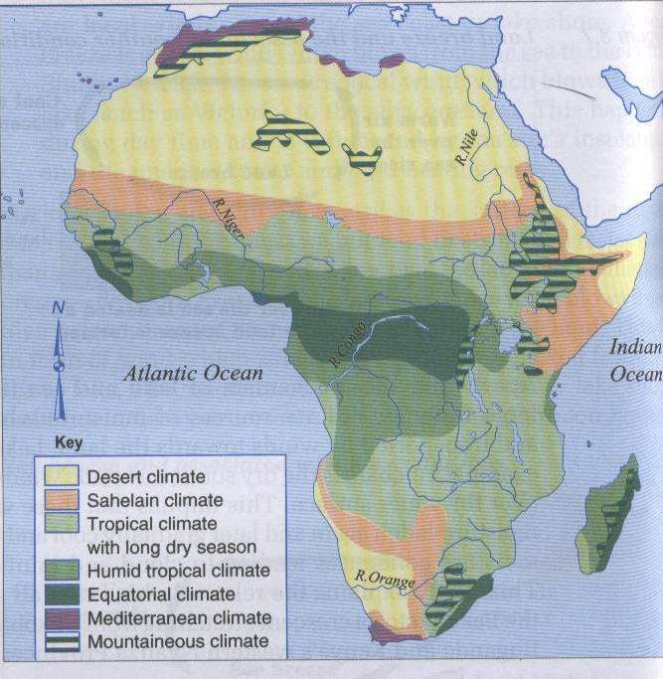

**Fig 3.7 Climatic regions of Africa**

**- Equatorial climate**: this climate is found in areas close to Equator within 5o South and 5o North. Those areas include much of Congo basin, the West African coast, and parts of Gabon, Equatorial Guinea and Cameroon. In East Africa, this climate is reduced by the factors of altitude and relief. However, equatorial climate is found in areas such as Lake Victoria shores and islands, highlands and Zanzibar islands. **The characteristics of equatorial climate are:**

* High mean annual temperature of about 27oC
* Uniformly high temperature with only a small annual range of about 3oC
* High relative humidity of about 80%
* Abundant rainfall of 2000mm on average
* Double maxima rainfall; two picks of rainfall exist usually around April and October each year
* Rainfall is accompanied by thunder and lightning
* Absence of distinct dry season

**- Savannah climate**: this is the most widespread climatic type in Africa. This climate is found in the south of the Sahara and Sahel region in West Africa, East and central Africa outside the Congo basin and major highlands. **The characteristics of this climate are:**

* Moderate rainfall usually between 760-1500mm
* The amount of rainfall varies from place to place. Places near Equator, especially near water bodies and highlands receive higher rainfall
* The rainfall is seasonal and in most cases characterized by one wet season and one dry season
* The temperature are high throughout the year
* High temperature range compared to the equatorial climate
* high relative humidity

**- Arid and semi-arid climate**: Africa is the home to the world largest desert: the **Sahara**. The Namib Desert is found in Namibia along the coast. The Kalahari semi-desert is an eastward extension of the Namib Desert and occupies much of Namibia, Botswana and the north-western part of the Republic of South Africa.

**Characteristics of this climate are:**

* Low relative humidity usually less than 25%
* Limited cloud cover or even clear skies
* Very law rainfall usually less than 760mm
* High day-time temperatures and low temperature at night
* High diurnal temperature range

**- Mediterranean climate**: this is known as warm temperate **western margin**. Areas experiencing this climate in Africa include south-west of the Republic of South Africa (Cape Town area), the coast of Morocco, Algeria and the Benghazi area of Libya. **This climate is characterized by:**

* Wet winters (rain fall is received in winter due to onshore winds in that season and offshore winds in summer).
* Dry summers
* Warm to hot summers
* Cool to mild winters

**- Montane climate**: this is experienced on the high mountains. The high grounds of Africa which have various micro-climates include the Atlas, Drakensberg, Adamawa and Ethiopian highlands. In East Africa, notable examples are Mount Rwenzori, Mount Kenya, Mount Kilimanjaro, Mount Elgon and Mount Muhabura (Rwanda). **The main characteristics of mountain climate include:**

* Very low temperature near and at the tops of the mountains
* Decrease in atmospheric pressure as altitude increases
* Relief rainfall on the windward side
* Dry leeward side

**3. Climate of other continents**

**a.EUROPE**

The climate

The continent of Europe stretches from northern mid latitudes to the polar region:

* The Mediterranean climate : southern part of Europe;
* The warm temperate coastal climate: experienced in Western Europe, in the British Isles, the Rhine lands, southern parts of Scandinavian countries;
* The warm temperate continental climate: S.E Europe, Balkan states, south central Russia. It is characterized by hot summers and cool winters;
* The cool temperate interior climate: Central Europe, over the Scandinavian countries, most of Northern Russia. It is known for its mild summers and cold winters;
* The tundra climate: polar north, cold summers and cold winters.
* Desert vegetation or dry steppe: temperate desert vegetation around the Caspian Sea. It is a cold desert. There is mostly desert shrub.
  1. **AMERICA**

The major climatic types found in North America include: Desert and semi-desert climate, western margin, Montana climate, Warm temperate Interior (Continental), Cool temperate western margin (West Coast), Warm temperate eastern margin, cool temperate eastern margin, cold temperate interior, cool temperate interior (Continental), Tundra, Polar climate.

**C .ASIA**

The cold Tundra of the Polar North, the hot, dry desert of the central and south-west, and the hot, humid of the tropical south.

Factors influencing the climate Asia: continentality, High mountains, Monsoon winds, latitude, longitude and the adjacent water bodies.

* 1. **OCEANIA**

i)With the exception of New Zealand and Easter Island, the Pacific Islands lie within the rainy tropics or the humid subtropics. In such areas there are no abrupt seasonal changes as occur in regions of temperate climate. Temperatures typically average close to 27° C (80° F) most of the year. At higher elevations, temperatures typically drop at the rate of 1.7° C (3° F) for every rise in elevation of 300 m.

ii)In parts of the central and western Pacific, monsoon climates prevail. In monsoon climates, moisture-bearing winds reverse direction once a year, creating a distinct wet season and a dry season. Because of monsoon conditions and differences in elevation, amount of rainfall, seasonal and annual, varies greatly from island to island and even on different parts of larger islands. The windward (usually eastern) slopes of the high islands sometimes receive as much as 6400 mm (250 in) of rainfall annually. The leeward (usually western) slopes of these islands are relatively dry.

iii)In the area from about 30° north of the equator to about 30° south of the equator, the westward-moving trade winds prevail. Centuries ago these steady winds carried the sailing vessels of European traders, hence their name. Where the northern and southern trade winds meet near the equator they cancel each other out, creating the doldrums, a region of little or no wind more formally called the intertropical convergence zone (ITCZ).

iv)The western Pacific is also a breeding ground for tropical cyclones, which are called typhoons in some areas and hurricanes in others. North of the equator most such storms occur between July and November. South of the equator the stormy season begins about November and ends about March. The heavy wind and rains brought by these storms often causes devastating loss of life and property.

**4. RELATIONSHIP BETWEEN CLIMATE AND HUMAN ACTIVITY**

**a) Positive aspect:** Climate as well, influences our day-to-day life as it gives us various opportunities for development.

1. **High and reliable rainfall** favours agriculture, moderate to heavy rainfall: coffee& banana, cool temperature for wheat

2. **Moderate or abundant rainfall** support grass which livestock can feed on as pasture

3. Heavy rainfall supports the growth of trees and thus forest existence (lumbering& forestry activities)

4. **Tropical warm and sunny climate** is attractive to European and North American tourists especially when it is winter time in their countries of origin (tourism industry earning of foreign exchange).

5. **Human activities** such agriculture depend on good climate.

6 .**Fishing** influenced by climate because the continued existence of wetlands and other water bodies is supported by the availability of rainfall.

7. **Favourable climates** have led to the occurrence and presence of many features such as forest, grasslands, wetlands and water bodies that form tourist attraction sites, but tourist can destroy the environment if they leave fire.

8 .**A good climate** with reliable rainfall supports mining especially of alluvial mineral deposits

9. **Industrialization** is affected by climate such agro-industry depend on good climate with reliable rainfall

11. **Settlement of all kinds** both in rural and urban areas are influenced by climate (favourable climate).

**b) Negative aspects:** Climatic conditions can, however, be a problem to development

1. **Excessive rainfall** may lead to flooding in low-lying areas (loss of life &destruction of properties)

2. **Dry hot climatic conditions** discourage the activity of cultivation (crops requiring abundant water may not be successfully grown in arid and semi-arid lands without irrigation)

3. **Much tropical rainfall** reduces the lifespan of roads, roads develop potholes and gradually deteriorate, this raises maintenance costs.

4**. Certain vectors** thrive best in hot tropical climatic conditions: mosquitoes and tsetse flies (malaria& sleeping diseases) are fundamentally tropical diseases

5. **Wind uproots** the trees and destroys properties, …

## 5.SUB-TOPIC AREA: VEGETATION

***UNIT 5: VEGETATION OF AFRICA AND THE WORLD***

1. **Introduction**

Vegetation refers to a set of natural or planted plants witch grow on a given surface of land, that is , in a given environment. Plants that cover the earth’s surface. Community of plants .All plants considered broadly are known as vegetation. **Natural vegetation** refers to plants whose growth is not a result of human activities but a product of natural processes and factors. **Human induced** or **artificial vegetation** refers to plants whose growth and development have been influenced by human beings.

**2. Types of natural vegetation Africa/Vegetation of Africa**

**+ Tropical rainforest vegetation**: this vegetation is found where the tropical equatorial climate is experienced. It is found in Congo basin, Sierra Leone, Ivory Coast, Equatorial Guinea and Gabon. In East Africa, the tropical rainforest is found around the Lake Victoria shores and islands, the highland areas and the coastal strip. This forest has the following characteristics:

* Closely packed tall rising trees to an average height of 50m
* Trees occur in **mixed stands**, meaning that different tree species grow next to each other
* Climbing plants, lianas (plants needing trees for support) and epiphytes (parasitic plants) occur amidst (between) the bigger trees.
* Occurrence of broad-leaved and evergreen trees
* Limited or absence of undergrowth (shorter or smaller plant communities) between the bigger trees
* Trees have developed buttress roots
* Trees branches are in layers (stratification). Three layers can be identified.

**+ Savannah woodland**: the woodland vegetation is characterized by:

* More or less continuous cover of trees; 8-16m tall
* Trees have bushy spreading tops
* Some trees shed their leaves during the dry season; hence are **deciduous**
* Dense undergrowth (the growth of shorter trees, bushes and grasses between taller trees)

**+ Savannah grassland**: this is the most widespread type of natural vegetation in Africa. It can be found in the interior of plateau of Kenya, Uganda and Tanzania. Areas of Bugesera and Akagera national park are known for their savannah grassland vegetation. The characteristics are:

* Relatively tall grass of about 1m on wet margins
* Occasional tall elephant grass of about 3 to 4m
* Scattered and widely spaced trees
* Scattered bushes

**+ Desert and semi-desert vegetation**: this vegetation is widespread over Sahara and Namib Deserts and Kalahari semi-desert. The vegetation has the following characteristics:

* Very short and widely spaced trees
* Very short grass (bare surface on very dry margins)
* Drought-resisting plants such as the cactus
* Plants with long and spreading roots to tap scarce water
* Plants with small, few and shiny leaves to minimize transpiration and reflect insolation
* Some plants have spines instead of ordinary leaves as a protective measure against herbivorous animals.

**+ Mediterranean vegetation**: this is found along the Algerian, Tunisian and Moroccan coasts. It is also found around Benghazi (Libya) and Cape Town (Republic of South Africa).

Major characteristics are:

* Trees with shiny and waxy leaves (to reduce transpiration and conserve limited water supply)
* Trees with thick bark (like cork oaks)
* Long tap roots that extend to great depths in the soil in search of water
* Certain plants with fleshy bulbous roots able to store water

**+ Montane vegetation (mountain/highland vegetation)**

This is vegetation found on high mountains which include Rwenzori, Elgon, Muhabura and Kilimanjaro. Plants are adapted to cold climatic conditions. The main characteristics include:

* Occurrence of sheath and moor plant species
* Growth of short grasses
* Growth of scattered low shrubs
* Occasional sprouting of flowering plants
* Absence of trees at or near the mountain summit (top) where temperature is less than 6oC for most of the year

**+ Wetland (swamp) vegetation**: this vegetation is found along the continent’s coastal strip as along sections of river valleys such as Nile, Nyabarongo as well as on the shores of lakes such as Victoria, Edward, Albert, Kyoga and Tanganyika. The main characteristics are:

* Papyrus plants
* Mangrove plants (trees growing in muddy and shallow water with roots growing from their branches into the water)
* Floating aquatic vegetation such as water lilies
* Plants usually have short roots since water is available at or near the earth’s surface

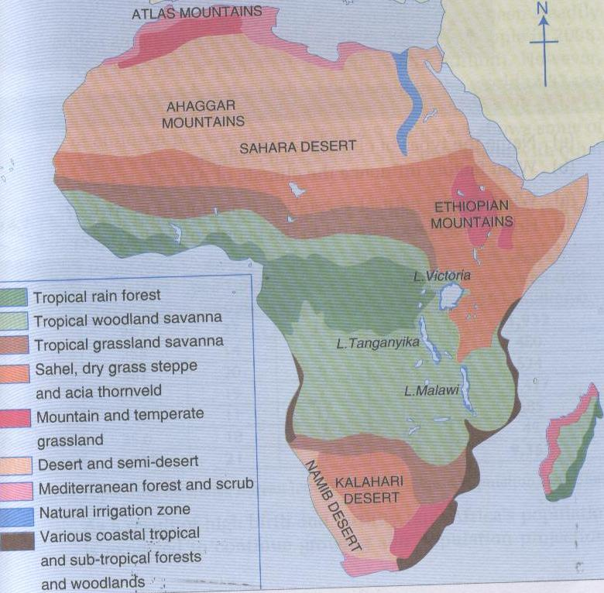

**Fig 3.9 Natural vegetation in Africa**

**Factors affecting distribution of natural vegetation**

**+ Climate**: rainfall and temperature are the main climatic elements which influence the type of vegetation. Abundant rainfall produces forest.

**+ Soil**: deep and rich loam soils on the gentle slopes support the growth of tall trees.

**+ Relief**: high rate of erosion on steep slopes results into thin soils while gentle slopes have thick or deep soils. Consequently grass may grow on steep slopes but trees and other forms of luxuriant vegetation will tend to grow on the gentle slopes.

**+ Drainage**: on flat or low lying areas where water is not freely flowing, that is where water is stagnant, drainage is said to be **poor** or **imbedded**. This leads to the growth of water-loving plants such as **water lilies**, **mangrove** and **papyrus**. Such areas are known as **swamps** or **wetlands**.

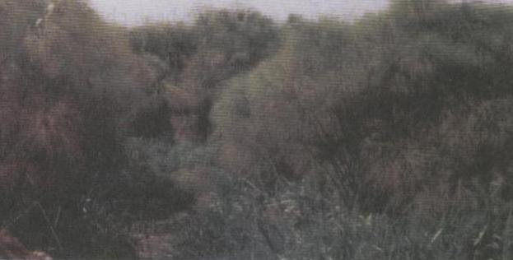

**Fig 3.8 Papyrus**

**+ Role of animals**: insects such as locusts and grasshoppers, wild herbivorous animals like large herds of elephants and large numbers of birds are examples of animals that may lower the quality of natural vegetation through their feeding patterns. When the number of herbivorous exceeds the land carrying capacity (the capacity of land to support living organisms on a given area), the existing vegetation will be destroyed through **overgrazing**. However, **Tsetse** flies protect the vegetation by preventing animals to make it a habitat!

**+ Human activities**: human activities include the grazing of domestic animals, burning, deforestation and reclamation projects.

**Importance of vegetation**

1**. Soil conservation:** Control soil erosion caused by raindrops, running water or strong wind

**2. Rainfall formation:** Trees transpire and release vapour into the atmosphere (evapo-transpiration)

**3. Wildlife habitat:** Forest/vegetations are home of various types of animals

**4. Source of oxygen:** Vegetation contributes oxygen which is needed by human beings

**5. Provision of food:** Some forest plants contain edible parts eg : mangoes trees,...

**6. Provision of building materials:** only from trees that timber and poles for construction are obtained

**7. Provision of charcoal and firewood:** Trees are cut down and processed to make charcoal and tree trunks and branches are also used as firewood.

**8. Source of medicine:** Traditional and modern medical systems in many part of the world are based on plants.

**9. Scientific Research:** Human kind is continually seeking to find more about the environment in an effort to improve people’s lifestyles.

**10. Tourism:** Cool forest environment with a variety of plants communities is source of pleasure to some people interested in observing nature in its real form.

11. Employment opportunity and foreign exchange

**12. Art, craft & culture:** In some part of the world, trees are used to make items of art and craft such as local tools

**13. Trees provide protection of settlements** against whirl/strong wind which would otherwise destructive

**14. Manufacture of paper:** Soft wood trees are significant as they are processed into paper products.

**NEGATIVE EFFECTS OF VEGETATION**:

1.Difficulties in the establishment of infrastructure, in dense vegetation and impenetrable forests makes construction of transport and communication routes difficult and more costly.

2.Pests and diseases, vegetation such as forests harbour dangerous pests and diseases which affect people leaving near them. 3.Species of less economic value 4.Obstacle to settlements 5.Wild animals 6.Hide-outs,forested areas and other bushy parts of the country act as hide-outs for criminals who interfere with peace and order in the neighbouring communities and act as short –cuts for illegal trade eg: *kanyanga.*

7.Socio-economic barriers, vegetation in the form of forests act as barriers between various communities especially those that live on opposite sides of the forested areas, communication between the two areas is hindered.

**3. Major type of vegetation in other continents**

**a.EUROPE**

The types of vegetation include:

* Mediterranean vegetation: mostly wood land and shrub. It referred to as maquis or garrigue, it is found in southern regions bordering the Mediterranean Sea.
* Deciduous forest: western Europe; forests shed their leaves during the winter season;
* Coniferous forest or taiga: composed of thin leaved conifers that are evergreen: Northern Europe (Sweden, Finland) Eastern and Northern Russia;
* Cool grasslands or temperate steppes: short grass with little or no trees: central and Eastern Europe;
* The arctic tundra: stunted vegetation and barren lands: Norway and Extreme North of Russia;
* Desert vegetation or dry steppe: temperate desert vegetation around the Caspian Sea. It is a cold desert. There is mostly desert shrub.

**b.AMERICA**

**North America:** Temperate deciduous forests, tropical evergreen forests, Mediterranean forests, temperate gross land, semi-desert and shrub, tundra.

**South America**: Coating: White forest, tropical deciduous forests, temperate rainforests, south Brazilian forests, Xerophytes association, and mountain vegetation.

**c. ASIA**

Asia incorporates many different biomes, which are landscapes having similar combinations of climate, vegetation, and animal life.

The northernmost areas of Asia, which experience a subpolar climate, have tundra vegetation consisting of grasses, mosses, and other small plants. Farther inland from the Arctic coast, the tundra gives way to the taiga, a region of vast coniferous forests composed of trees such as spruce, larch, and fir. Farther south, the taiga merges with forests of broadleaf trees, or mixed forests of broadleaf and needleleaf trees.

In Asia’s north central interior the forests merge into vast grasslands, much of which is short, steppe grasses. Large portions of Southwest Asia and the continent’s interior have semiarid or desert vegetation. Short grasses and other vegetation that require minimal precipitation surround many of the most barren areas in the deserts.

Although tropical rain forest predominates along the southern coastal strip and on the island of Sri Lanka, the eastern side of South Asia is characterized by semiarid tropical vegetation. The Deccan Plateau has mainly tropical dry forest vegetation.

Mainland and island Southeast Asia once supported extensive areas of tropical rain forest, which thrived in the warm, moist climate. Significant tracts of forest remain in most countries, but legal and illegal harvesting are too rapid to support sustainable regrowth.

Inland from the coastal strips of mainland Southeast Asia and stretching into southern China, tropical seasonal forests predominate. These merge into temperate forests farther north. Around the rim of the Bo Hai gulf the vegetation is chaparral, woody shrubs that grow to 4 m in height.

**d. OCEANIA**

The vegetation of the Pacific Islands varies by island type. The continental islands have vegetation typical of tropical climates: Mangrove forests rim the island, further inland lie nipa and other palms, and the interior is typically rain forest or monsoon forest. At higher elevations are temperate forests, including pine trees. The highest elevations of New Guinea even have alpine forests. In some areas of continental islands and larger volcanic islands, soil fertility can be high, especially in river basins and deltas.

**4. RELATIONSHIP BETWEEN VEGETATION AND HUMAN ACTIVITY**

1. **Forestry:** Science of managing forests=uses of trees in different activities eg : lumbering, timber, poles,…

2**. Charcoal burning** and **firewood** collection as source of energy. 3. In grassland environments, the available **grass** is used as pasture for herbivorous animals: **pastoralism**(goats, sheep, cattle,…)

4. Unique high altitude vegetation and mountains slope vegetation tends to be a source of curiosity, this leads to the growth of **tourism industry**.

## 6.SUB-TOPIC AREA: DRAINAGE

***UNIT 6: DRAINGE IN AFRICA***

### 1.Introduction

**Drainag**e refers to the total network of water bodies over the surface of the earth. These Include lakes, rivers, canals, springs and swamps. It is general distribution of surface water. A **drainage system** is layout or actual plan made by the river and its tributaries on the landscape. **A drainage basin** is therefore a Low lying area drained by either a lake or a river.

1. **Major rivers and lakes in Africa**

**River :** water flowing in a definite channel towards a lake or sea e .g Nyabarongo river, Akagera .There are thousands of rivers originating from the continents uplands. The Nile is the longest while Congo is the largest of African rivers. Other important rivers include Zambezi, Niger, Limpopo, Volta and Orange. Africa’s bigger rivers reach a river’s normal destination (sea). Nile, Congo and Orange are examples. However, some smaller ones are unable to reach the sea and instead flow into lakes. The situation by which a river does not reach the sea but flows into lakes is called **inland drainage**. Notable examples of inland drainage include Lake Chad, Okavango swamp lands (Botswana) and Lake Magadi (Kenya). Most of Lakes in Africa are located in Eastern Africa west led in and around Africa’s Great Rift Valley: **The eastern Rift branch** contains lakes Magadi, Nakuru, naivasha, Elementeita, Bogoria and Turkana **while the western Rift branch** consists of Lake Tanganyika (1470m deep; the first in depth in Africa, the second in the world after Baikal in Russian federation), Lake Malawi, Albert, Kivu, George, Rukwa and Eduard. Lake **Victoria** (68500km2) is the largest lake in Africa. It does not lie in the rift valley but it is located between its main valley and the western branch and for this reason it is called a lake of **warping**. The Lake Chad is shared by Niger, Chad, Cameroon and Nigeria.

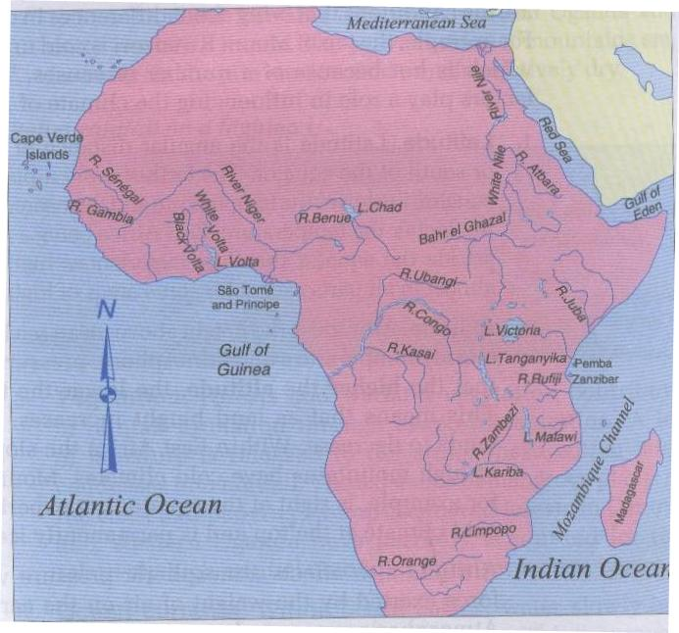

**Fig 3.4 Major drainage features**

**Major drainage basins of Africa**

Drainage refers to the total network of water bodies over the surface of the earth. This Includes lakes, rivers, canals, springs and swamps . A drainage basin is therefore a Low lying area drained by either a lake or a river In Africa the major lake basins include Victoria basin , the Chad basin , and other smaller bodies drained by smaller lakes. The river basins are the low lying areas drained by rivers. Drainage basins are separated by highlands called divides The major river basins in Africa include the Congo basin, The Nile basin and Nyabarongo basin (Rwanda )..

**The congo basin: This** basin drains from Bunia highlands of East African rift valley, Lake Tanganyika, Mweru as Lualaba river. The basin is drained by the Chambezi Lomani at Kisangani .It joins with R. Ubangi at Kinshasa to Matadi, Boma and the Atlantic Ocean.

**The Niger basin :**This basin is West Africa’s longest river.It flows from Guinea highlands through Mali, Niger ( on the border with Benin ) then through Nigeria to the Niger delta and to the Atlantic Ocean

**The Nile basin** : The basin covers D.R Congo, Kenya , Uganda, Tanzanie,Rwanda, Burundi,Sudan, Ethiopia as well as Egypt.The white Nile rises in the Southern Rwanda, flows Northwards to Tanzania ( Kagera ) into L. Victoria, kyoga (Victoria-Nile ) into L. Albert, Albert Nile into Southern Sudan. The Blue Nile starts from Lake Tana in Ethiopia and flows into Sudan,where it joins the White Nile near Kharthoum

**The Nyabarongo basin**.: River Nyabarongo is the single longest river in Rwanda.It a flows from the highlands of Gahinga / Muhabura mountains to form R. Mukungwa in Nyabihu regions. It is joined by tributaries from Mutaza hills in the west. The river flows southwards to Gakenke and splits into two distributaries, one flows south of Kigali to L. Mugesera plains into R. Rweru on the border with Burundi. Another tributary flows southwards.It is joined by R. Mbirurume,Rukarara from the Nyamasheke highlands.It develops several distributaries in Nyamagabe, Huye region in the Nyanza plateau.

# Major lakes of Africa and their mode of formation

**1°Definition**

A lake is hollow or depression in the earth’s surface containing water .It is more or less large and deep areas of water found inside the mainland ( continent ) . Lakes can be temporary or permanent .

**2°Types of lakes ( modes of lakes formation )**

*I Tectonic ( Earth movement ) lakes

a) Down warped basin lakes : These are which occupy down warped depressions. Examples include lakes Victoria and kyoga.

b) Fault lakes ( Rift Valley lakes ): These are formed when depressions on the rift valley floor are filled with water ana become sites of lakes, after faulting.Examples include lakes Tanganyika, Albert, Magadi , Kivu, Edourd, Turkana and several others

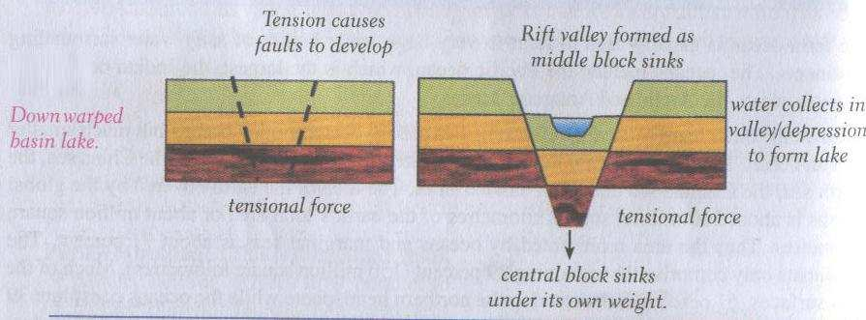

* II° Glacial Lakes : these are formed due to erosion and deposition by glaciers They include :

- Cirque Lakes (Tarns ): these form when a depression ,created by glacial erosion in highland areas is filled with water as the glacial melts ;E.g Michelson and Teleki on Mt Kenya, Mahoma on Mt Ruwezori .

- Rock basin lake: these are formed when unequal vertical glacial erosion within the U-Shaped Valley leads to formation of rock basins which become sites of lakes when the soft rocks are eroded on the valley floor . E.g. Lac’duspeke in the upper Mobuku Valley on Mt Ruwenzori .

- Ribbon Lakes: these also form within the U-shaped valley.

- Moraine dammed Lakes: these are a result of glacial deposition of terminal moraine which traps water behind, to form moraine dams of melt waters

**c) Volcanic Lakes:**

*Crater (Caldera) Lakes : these form when craters or calderas become sites of lakes when filled with water after volcanic eruptions .E.g on Bushokoro

,Muhabura, Karisimbi volcanoes , Lake Ngozi near Mbeya on Mt Rugwe with a depth of 75m in Tanzania ,Lake Nyungu and Lake Nyamununka in south western Uganda ;

*Lava dammed lakes: these are formed when lava outflow across a river channel blocks the river water which becomes stagnant to form a lava dammed lake. E.g Lakes Ruhondo,Mutanda,Bunyonyi, and Kayimba in South Western Uganda.

*Man-made Lakes: these are formed as a result of man’s activity through dam

Construction, mining and other related activities.

**4. Features related to rivers in Africa**

**a.Work of Rivers / Functions Rivers**

Rivers perform three major functions : Erosion , Transport and deposition

1. **Erosion work of rivers** : erosion involves the remoral of geomaterials from the rocks and other deposited materials and depends on channel gradient, volume of water , velocity , Kinetic energy , water discharge , sediment load .
2. **Transport by rivers** : is the movement of the sediment load of the rivers and include : gravels , sands , silt and clays .
3. **Deposition by rivers** : it refers to the situation where a river drops its load due to reduction in its energy . the heavy load is selectively deposited the first while the fine and lighter last .

N.B : Erosion and transport are dominant in the upper and middle course while deposition in the lower course / stage .

**b. River Erosion and its processes**

Erosion occurs where a stream has excess energy . The river erodes its banks and bed through four major processes through which river deepens and widens its valley .

1. **Attrition** : this is the process through which eroded particles hit and collide with each other while in motion , they are reduced in the size , hence giving room for more erosion and consequently widening and deepening the river valley.
2. **Corrosion ( abrasion**) : in the process , the sides and valley bed wear away by the load of the rivers . the load in motion hits against the stationary rocks on the valley sides and bed ( floor ) thus wearing and abrading the valley.
3. **Solution ( corrosion** ) or chemical action : this is the process through which the river valley is eroded by the solvent action of the water as it flows overt the rocks . water dissolves the soluble rocks on the valley sides and bed hence carrying them away in solution .
4. **Hydraulic action** : this is the process by which the river valley is eroded through the singing of water into the cracks and joints of the rock.

**Erosional landforms**

The significant landforms resulting from fluvial erosion by streams include:

1. **River valley :** the valleys carved out by the rivers are significant erosional landforms

Gorges and canyons : are very deep and narrow valleys with step sides / slopes

1. **Waterfall and rapids** : waterfalls or simply falls are caused by sudden descents or abrupt breaks in the longitudinal cause of the river due to factors like :

* Variation in the relative resistance of rocks
* Relative difference in topographic reliefs
* Fall in sea level and related rejuvenation
* Earth movement
* Waterfall is a vertical drop of a big volume of water from a great height along profile of a river
* Rapids are much smaller that waterfall , they are found up stream from the main falls

**3.potholes :** these are kettle-like and cylinder –shaped depressions in the rocky beds of the river valley ; and are formed in coarse grained rocks (=sandstone and gramites)

**4.benches :** the step –like flat surfaces on either side of the valley floor are called river terraces .

5. River terraces : the narrow flat surfaces on either side of the lowest valley floors are called river terraces of the rivers.

**6 . Meanders :** bends of longitudinal courses of the rivers.

**7.Peneplains :** low features less plains having undulating surfaces and remnants of convexo-concave residual hills . These are the end products of a normal cycle of erosion

**c. River transport and its processes**

**A** river transports its load in four major processes. River load refers to the eroded materials being transported or deposited by river.

1.**Saltation** : in this processes , the smaller rock particles are carried along the river –bed in a series of hops and jumps as picked and dropped over and again . (= rough river bed )

2.**Suspension** : this is when small and light insoluble particles like silt are carried by water in a suspended form ( floats )

3.**Traction** : this is when big particles such as boulders and pebbles which can not be carried through the other processes are rolled on the valley bed . (= when valley bed is smooth )

4.**Solution** : this is when the eroded rocks get dissolved in water . they are carried away in a solution form.

**River deposition**

Deposition of the load ( eroded materials ) occurs when the river has insufficient energy to transport its load any more . The material deposited is called **alluvium** .

River deposition results into the formation of the following feature :

**i) alluvial fans :** these are fan-shaped deposits of coarse alluvium , they are formed when a fast flowing river loses its velocity when it enters the plains

ii. **ox-bow lakes : the** lakes formed due to stagnation of water in the abandoned meander loops (=horse –shoe lakes = ox=-bow lake ) they are formed when a river develops pronounced meanders on the flood plains.

**iii) River meanders**

**iv) peneplains**

**v) Levees** : these are raised river banks made up of alluvium . they are formed when a river deposits its load during flooding .

vi . **deferred tributaries** : the raised nature of river banks stop tributaries from joining the main stream. They flow parallel to the main river until they encounter a break in the river bank where they now can join the main stream.

vii**. braided channel** : it is a wide and shallow channel where a river breaks into a series of interconnecting distributaries separated by sand banks and island a of alluvium . It is formed in the middle or old stage.

Viii. **Delta** : the depositional feature that is almost triangular in shape at the mouth of a river into either a lake or a sea . a delta is a low-lying swampy plain , which gradually becomes colonized by various types of plants.

**5. The importance of rivers, lakes and wetlands in Africa**

**a.River**

* Rivers and areas of winter facilitates irrigation in agriculture ( farming )
* Areas of water serve daily domestic needs for drinking, cooking,construction
* Areas of water serve as navigation routes used in transporting people and goods.
* Some rivers have waterfalls. From these falls, barrages are set up produce electric Power.
* Areas of water serve as tourist sites.
* Areas of water contain fish serving s food for both humans and animals.
* Waters freshen the climate.

**b. importance of lakes**

-Source of proteins and fact -Transport and communication avenues

-Source of raw materials for industries -Source of minerals

-Tourist attractions -Revenue to the government.

-Employment to man -Modify local climate

-Act as political boundaries -Reservoirs for irrigation schemes

-Sites for dumping waste -Place for breeding of wild animals

-Help to generate HEP - Lakes regularise river flow

-Source of water for industrial and domestic use.

**c.Wetland**: A piece of wet, spongy land: low ground saturated with water.

1. They are source of water, 2.Natural water purification system, 3.Fishing activity, 4.Homeland for flora and fauna 5. Source of raw materials, 6.Provision of clay, 7.Source of food,8. Grazing area, 9.Modification of climate 10. Source of medicine, 11.Reduction of occurrence of floods, 12.Recreational resource, 13.Sanctuary for birds

**The relationship between human activities and areas of water**

Waters influence human activities.

**1°Industrial areas**

Some industries (factories), especially those consuming much water are planted near lakes, seas and rivers

e.g . Breweries, aluminium industries

**2°Favourite areas for tours and suburbs Installation of economic activities.**

thanks to harbour and piscicultural activities

**3°Installation of economic activities**

**-**People and goods transport

-Marine, lake and fresh water fishing, sand extraction

-Organisation of tourist activities.

**4°Scientific research sites / areas**

**6.Challanges to obtain sustainable clean water in Africa**

1.Misuse of water resources, 2.Water pollution, 3. Soil erosion, 4. Development and construction, 5. Weeds and aquatic animals, 6. Straightening and dredging of rivers, 7. Climatic changes, 8. Urbanization. 9. Sewage and garbage disposal, 10.Water scarcity.11.Silting/sedimentation.