**KICUKIRO DISTRICT**

**NYARUGUNGA SECTOR**

**ES KANOMBE/EFOTEC**

**PHYISICAL GEOGRAPHY REVISION EXERCISES FOR S6**

**Instructions: All questions are compulsory**

**1) a**) what is plate tectonics

**b)** Discuss the 2 effects of the plate’s tectonics in some specific areas of the world

**2)** By illustrating your answer describe the features of underground cave Limestone cave **(3 marks)**

**3)** List three influences of the sun on the Earth

**4)** Give a brief description of inselberg and mushroom rocks and illustrate your answer by using their diagram.

**6)** Discuss about the types of coral reefs

**7)** What are the five characteristics that are shared by all minerals

**8)** Examine the meaning of Greenhouse effects

**9)** Give the types of lakes produced by volcanicity

**10) a)** Explain two characteristics of equatorial rain forest

**b)** What are the two adaptations of desert vegetation to the harsh climatic conditions?

**11)** The senior six students were requested to conduct a fieldwork study on the landforms associated with river action along river Akagera:

**a)** State 3 objectives of study

**b)** Describe any two methods you would use to record data collected

**c)** Explain any three problems you are likely to face during the field study

**d)** Mention any two instruments or equipment you might have used in the collection of data

**12)** Study the photography below and answer the following questions:

**a)** What is the economic activity, which is represented on the photograph?

**b)** Outline two utilities of this activity to the development of the area

**c)** What are the two problems this economic activity is likely to face?

**d)** Giving evidences, explain the factors, which have favoured the activity identified in (a) above

**e)** Giving reasons for your answer, suggest an area in Rwanda where this photograph could have been taken

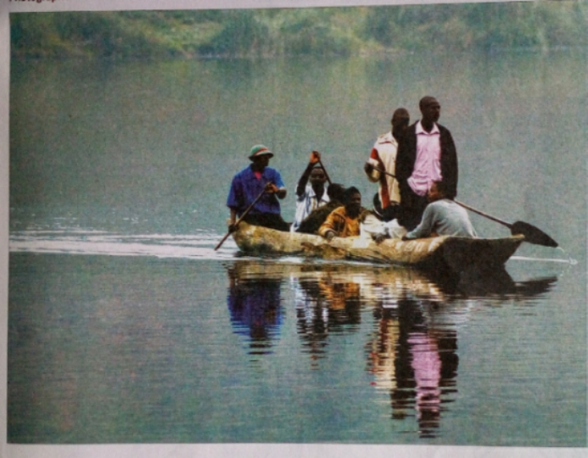

**13)** Study the extract of the map to the next page and answer to the related questions:

**a)** Give the six grid references of: Rubayo NW

**b)** Measure the distance from MUTOVU (601202 ) to GATARE 601500

**c)** Explain the importance of lake Bihiga and Lake Cyunyu to the people of Karago

**d)** Reduce the map by ½ and on it mark Lakes Cyunyu and lake Bihinga

**e)** Explain Why the North –East to South East and the Centre of the map records low level of settlement

f Calculate the area of the feature found at the East of Easting 90 and South of Northing20

END

