**BIOLOGY HOLIDAY ACTIVITY FOR S2**

**I. Multiple choices.** Choose the letter that corresponds to the correct answer.

Q1. Which one of the following functions is performed by only a modified leaf?

A. Food manufacture

B. Gaseous exchange

C. Vegetative propagation

D.Transpiration **(1mark)**

Q2. Which one of the following is a method of preventing tapeworm infection?

A. Wearing shoes

B. Boiling drinking water

C. Proper disposal of faeces

D. Treating infected individuals  **(1mark)**

Q3. Which of the following is a taxonomic class?

A. Annelida

B. Arthropda

C. Arachnida

D. Platyhelminthes **(1mark)**

Q4. When testing for non-reducing sugar in a solution, Hydrochloric acid is added to the solution in order to

A. Provide a suitable Ph

B. Kill any bacteria in the solution

C. Hydrolyse the non-reducing sugar

D. Catalyse the reaction **(1mark)**

Q5. When a seedling is placed on a klinostat, no curvature is occurs because

A. Auxins are not produced

B. Growth is accelerated

C. Auxins are uniformly distributed in the growing parts

D. All parts of the seedling are uniformly lit. **(1mark)**

Q6. Which one of the following is a difference between is a difference between an adult and newly hatched nymph of a cockroach?

**Adult**  nymph

A. Has three pairs of legs has no leg

B. Has compound eyes has no eyes

C. Has wings has no wings

D. Has a pair of antennae has no antennae **(1mark)**

Q7. Which of the following features is used to determine whether leaves are compound?

A. type of venation

B. type of stalk

C. Presence or absence of leaflets

D. Nature of margin **(1mark)**

Q8. Which one of the following sets of carbohydrates are monosaccharide?

A. Lactose, maltose, sucrose

B. Lactose, maltose, glycogen

C. Glucose, fructose, galactose

D. Sucrose, lactose, cellulose **(1mark)**

Q9. Which of the following sets of bones make up the hind limb in humans?

A. Radius, tibia, fibula

B. Tibia, fibula, humerus

C. Femur, tibia, fibula

D. Tibia, radius, ulna. **(1mark)**

**II.** **OPEN QUESTIONS**

Q10. From the following environmental factors, select those that are abiotic and those that are biotic: sunlight, parasites, symbionts, wind, competition, mineral salts. **(2marks)**

Q11.Explain how microscopic animals can survive without having a circulatory system. **(3marks)**

Q12. Suggest why it is difficult to decide whether viruses are living organisms. (**2marks)**

Q13. Amoeba are single-celled animals. The diagram below was drawn by students after observing the amoeba under microscope.

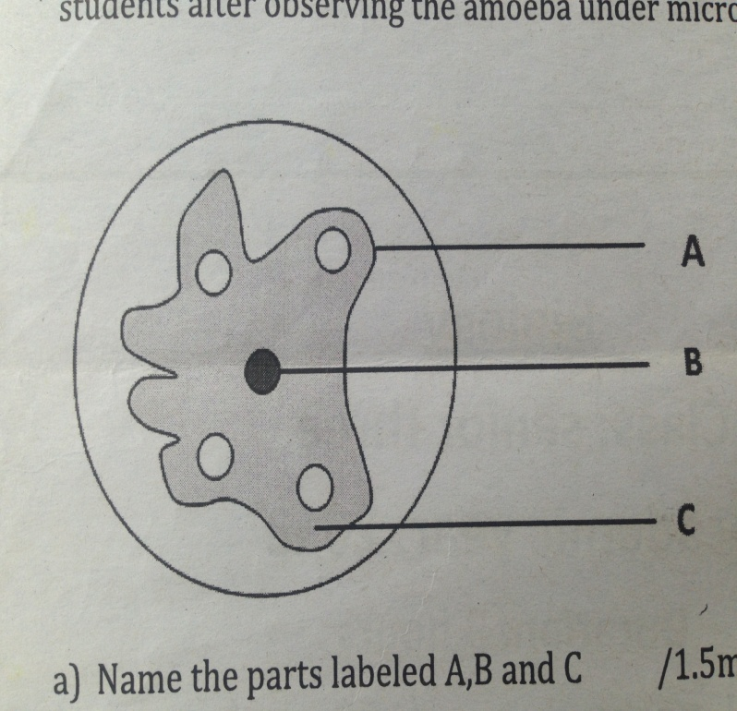

a) Name the parts labeled A, B and C. **(1.5marks)**

b) Draw lines to link each part of the amoeba cell with its function. **(1.5marks)**

**PART FUNCTION**

A Where chemical reaction take place

B Allows substances to move in and out of the cell

C Controls the characteristics of the cell

c) In which of these parts of amoeba would you find genes? **(1mark)**

Q14. A car is a machine, not a living organism, but it has several features in common with a living thing. How car is similar to a living organism and in what important ways is it different? **(1.5marks)**

Q15. a) Explain the meaning of the term locomotion. **(1mark)**

b) Distinguish between a tendon and ligament. **(2marks)**

c) A part from locomotion, state two functions of bones. **(1mark)**

Q16. A group of students studied the feeding relationship in a pond. The food web below shows their results.

Heron

Water bettles Pike Perch

Tadpoles Minnow

Weeds and Planktons

a. What information is given by the arrows in this food Web? **(1marks)**

b. A disease killed most of the minnows. Explain the likely effect of the death of most minnows on the following organisms in the pond:

i) Perch **(2marks)**

ii) Tadpoles **(2marks)**

iii) Planktons **(2marks)**

Q17. a. Describe the composition of blood. **(1.5marks)**

b. Explain how blood cells transport Oxygen. **(1.5marks)**

c. How are red blood cells adapted to transport oxygen? **(2marks)**

d. Explain why animal cells burst when in water but plant cells do not. (**2marks)**

Q18. a. Write four characteristic features which are found in mammals but not found in other vertebrates. **(2marks)**

b. Copy and complete the table below. **(4marks)**

|  |  |  |
| --- | --- | --- |
| **Animal** | **Phylum** | **Class** |
| Butterfly |  |  |
| Toad |  |  |
| Centipede |  |  |
| Elephant |  |  |

c. Which features adapt birds for flying? **(3marks)**

Q18. Malaria is the most disease in Africa.

a. What causes Malaria? **(1mark)**

b. How does it infect people? **(1mark)**

c. Describe all possible means you can recommend to prevent this killer disease. **(8marks)**

Q19. a. Name two foods which are good source of proteins. **(2marks)**

b. Explain briefly why the human body needs proteins. **(2marks)**

c. Describe an experiment you would carry out to tests for proteins in a piece of food. Say what you would expect to see if protein is present. **(3marks)**

d. Human saliva can change at 1% starch solution into maltose solution. Explain why digestive juice from the human stomach would not have this effect. **(3marks)**

Q20. a. Name a flying mammal? **(1mark)**

b. A frog is not a reptile. Give two reasons. **(2marks)**

c. What is the difference between *cold-blooded* and *warm-blooded* animls? **(2marks)**

d. A Student says, “Most warm-blooded animals take care of their young. Most cold-blooded animals do not.”

Is this statement correct or not? **(5marks)**

Q21. What is the difference between class Arachnida and class Crustacea?

Q22. Explain why animals in class Amphibia must always lay their eggs in water.

Q23. Give an explanation for each of the following observations.

(a) A dolphin resembles a fish but it is in class Mammalia.

(b) A bat resembles a bird but it is in class Mammalia.

(c) A Kangaroo has a pouch in its belly.

Q24. Which characteristics are used to group phylum Arthropoda into different classes?

Q25. Give the similarities and differences between Diplopoda and Chilopoda by filling the following table.

|  |  |  |
| --- | --- | --- |
|  | **Similarities** | **Differences** |
| **DIPLOPODA** |  |  |
| **CHILOPODA** |  |  |

Q26. The table below shows the concentration of sodium and iodine ions in pond water and in cell sap of an aquatic plant.

|  |  |  |
| --- | --- | --- |
| Ion | Concentration in pond water(PPM) | Concentration in cell sap(PPM) |
| Sodium | 120 | 70 |
| Iodine | 0.2 | 400 |

(a) Through which process in the sodium and iodine ions taken up by the plant. **(1mark)**

(b) Which ion would stop being taken up if the plant is treated with a metabolic poison that it inhibits ATP synthesis? **(1mark)**

(c) Suggest a reason to explain why terrestrial plants which are waterlogged slow down the uptake of certain minerals. **(2marks)**

(d) Name four processes in living things that depend on active transport. **(2marks**

Q27. An ecologist carried out a survey to estimate the number of organisms in a certain dam. The following table shows the record of this survey:

|  |  |
| --- | --- |
| Organism | Estimated number |
| Microscopic plants  Small fish  Mosquito larvae  Crocodile  Large fish | 435 000  120  4100  12  80 |

(a) Which of the above organisms are called the

(i) producers? **(1mark)**

(ii) primary consumers? **(1mark)**

(iii) consumer of the last order? **(1mark)**

(b) Which organisms are likely to finish first in the dam? Give a reason to support your answer. **(2marks)**

(c) Draw a food web for the above organisms to show the energy flow. **(1.5marks)**

(d) Draw a pyramid of numbers of the food chain that would be formed by the above organisms. **(2marks)**

(e) Explain why the number of organisms usually decrease at each successive level. **(1.5marks)**

Q28. A solution containing starch and glucose was put in a Visking tube in the set up shown in diagram below and left to stand for 30 minutes.

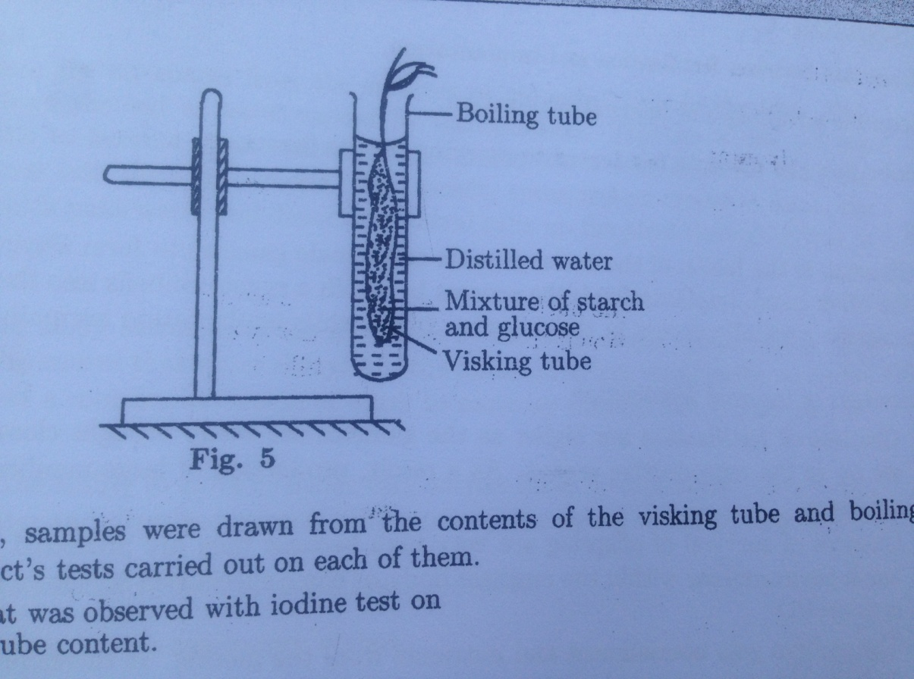

After 30 minutes, samples were drawn from the contents of the visking tube and boiling tube, then iodine and Benedict’s tests carried out on each of them.

(a) Describe what was observed with iodine test on

(i) visking tube content. **(1mark**)

(ii) boiling tube content. **(1mark)**

(b) Explain your observations in (a). **(2marks)**

(c) Describe what was observed with Benedict’s test on

(a) visking tube content. **(1mark**)

(b) boiling tube content. **(1mark)**

(d) Explain your results in (c). **(2marks)**

(e) Giving reasons, state the nature of the visking tube

--------------------END----------------