**BIO S3 REVISION QUESTIONS AND CONTENT TO BE REVISED**

1.CONTENT: **SENIOR ONE F**ROM **UNIT 1 TO 14**

**SENIOR TWO** FROM **UNIT 1 TO 12.**

**2. QUESTIONS**

**BIOLOGY S2 REVISION QUESTIONS AND QUIZ.**

**QUIZ: QUESTIONS NUMBER: 1, 2, 6,7, 8, 9 and 11.**

**REVISION QUESTIONS: No 3,4, 5,10 and 12**

1. a. Organisms belonging to the class Insecta do not grow large .Suggest reasons to explain why this is so.

b. Compare the general characteristics of class chilopoda and diplopoda.

c. Name the only class arthropoda without antennae.

2. a. State the criteria used to divide the phylum arthropoda into five main classes.

b. Give tow examples of organisms belonging to class crustacean.

c. What are the general characteristics of the class crustacea.

3. a. Write seven characteristics features which are found in mammals but not found I other vertebrate animals.

b. What are the characteristic features of insects?

4. The diagram below represents the structure of the fish. Study the diagram and answer questions that follow.



a) Name parts from A- G.

b) State a function of the parts A, F and C.

c) Name the structures you would see if the part B is removed and state a function of those structures.

d) To which phylum does fish belong?

5. a. Describe the ways in which birds are adapted for flying.

b. How is the frog adapted to live in water?

6. a. Name a flying mammal? **(1mark)**

b. A frog is not a reptile. Give two reasons. **(2marks)**

c. What is the difference between *cold-blooded* and *warm-blooded* animals? **(2marks)**

d. A Student says, “Most warm-blooded animals take care of their young. Most cold-blooded animals do not.” Is this statement correct or not?

7. The table below shows the concentration of sodium and iodine ions in pond water and in cell sap of an aquatic plant.

|  |  |  |
| --- | --- | --- |
| Ion | Concentration in pond water(PPM) | Concentration in cell sap(PPM) |
| Sodium | 120 | 70 |
| Iodine | 0.2 | 400 |

(a) Through which process in the sodium and iodine ions taken up by the plant.

(b) Which ion would stop being taken up if the plant is treated with a metabolic poison that it inhibits ATP synthesis?

(c) Suggest a reason to explain why terrestrial plants which are waterlogged slow down the uptake of certain minerals.

(d) Name four processes in living things that depend on active transport.

8. An ecologist carried out a survey to estimate the number of organisms in a certain dam. The following table shows the record of this survey:

|  |  |
| --- | --- |
| Organism | Estimated number |
| Microscopic plants  Small fish  Mosquito larvae  Crocodile  Large fish | 435 000  120  4100  12  80 |

(a) Which of the above organisms are called the

(i) producers?

(ii) primary consumers?

(iii) consumer of the last order?

(b) Which organisms are likely to finish first in the dam? Give a reason to support your answer.

(c) Draw a food web for the above organisms to show the energy flow.

(d) Draw a pyramid of numbers of the food chain that would be formed by the above organisms.

(e) Explain why the number of organisms usually decrease at each successive level.

9. A solution containing starch and glucose was put in a Visking tube in the set up shown in diagram below and left to stand for 30 minutes.

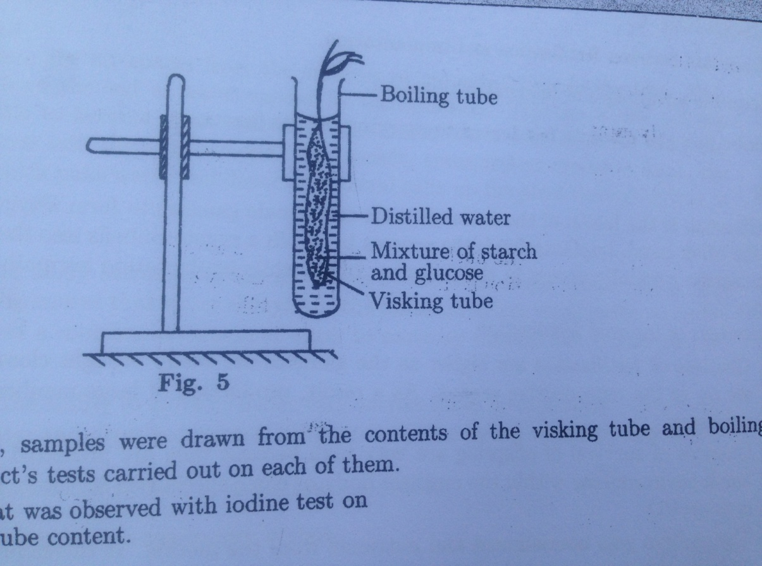

After 30 minutes, samples were drawn from the contents of the visking tube and boiling tube, then iodine and Benedict’s tests carried out on each of them.

(a) Describe what was observed with iodine test on

(i) visking tube content.

(ii) boiling tube content.

(b) Explain your observations in (a).

(c) Describe what was observed with Benedict’s test on

(a) visking tube content.

(b) boiling tube content.

(d) Explain your results in (c).

(e) Giving reasons, state the nature of the visking tube.

10. During an ecological tour of Lake Muhazi, a group of students from Kanombe Secondary school recorded the following observations.

(i) Tilapia feeds on mosquitoes larvae.

(ii) Mosquito larvae feed on planktonic algae.

(iii) Planktonic crustaceans feed on planktonic algae.

(iv) Hawks feed on tilapia, worms and planktonic crustaceans.

(a) From this record of observations, construct a food web.

(b) From the food web you have constructed in (a) above, isolate and write down a food chain that ends with

(i) Hawk as a secondary consumer

(ii) Hawk as a tertiary consumer

(c) (i) Which group of organisms in this lake are the producers?

(ii) The biomass of the producers in this lake was found to be greater than that of the primary consumers. Give an explanation for this observation.

11. Slices of onion epidermis were placed in different concentrations of sucrose solution. The percentage of plasmolysed cells was determined after thirty minutes. The results were as follows:

|  |  |  |  |  |  |  |  |  |  |  |  |  |  |  |  |
| --- | --- | --- | --- | --- | --- | --- | --- | --- | --- | --- | --- | --- | --- | --- | --- |
| Conc. of sucrose solution (Molar) |  | 0.55 |  | | 0.6 |  | | 0.65 |  | | 0.7 |  | | 0.75 |  |
| % of plasmolysed cells |  | 0 |  | 5 | |  | 20 | |  | 80 | |  | 100 | |  |

(a) What does the word plasmolysis mean?

(b) What causes plasmolysis of cells?

(c) Does plasmolysis also occur to animal cells? Explain.

(d) Explain the results of 0.55 molar sucrose solution.

(e) What is the relationship between molar concentration of sucrose solutions, and percentage of plasmolysed cells?

(f) What description or term would be used on a plant where 100% of its cells were plasmolysed

12. a. Tom was using a hand lens in the laboratory .He noticed X8marking on the frame of the lens .What was the possible indication of X8 markings?

b. List the steps that Tom could have followed in order to magnify the specimen.

c. Calculate the magnification of the diagram in the figure below:

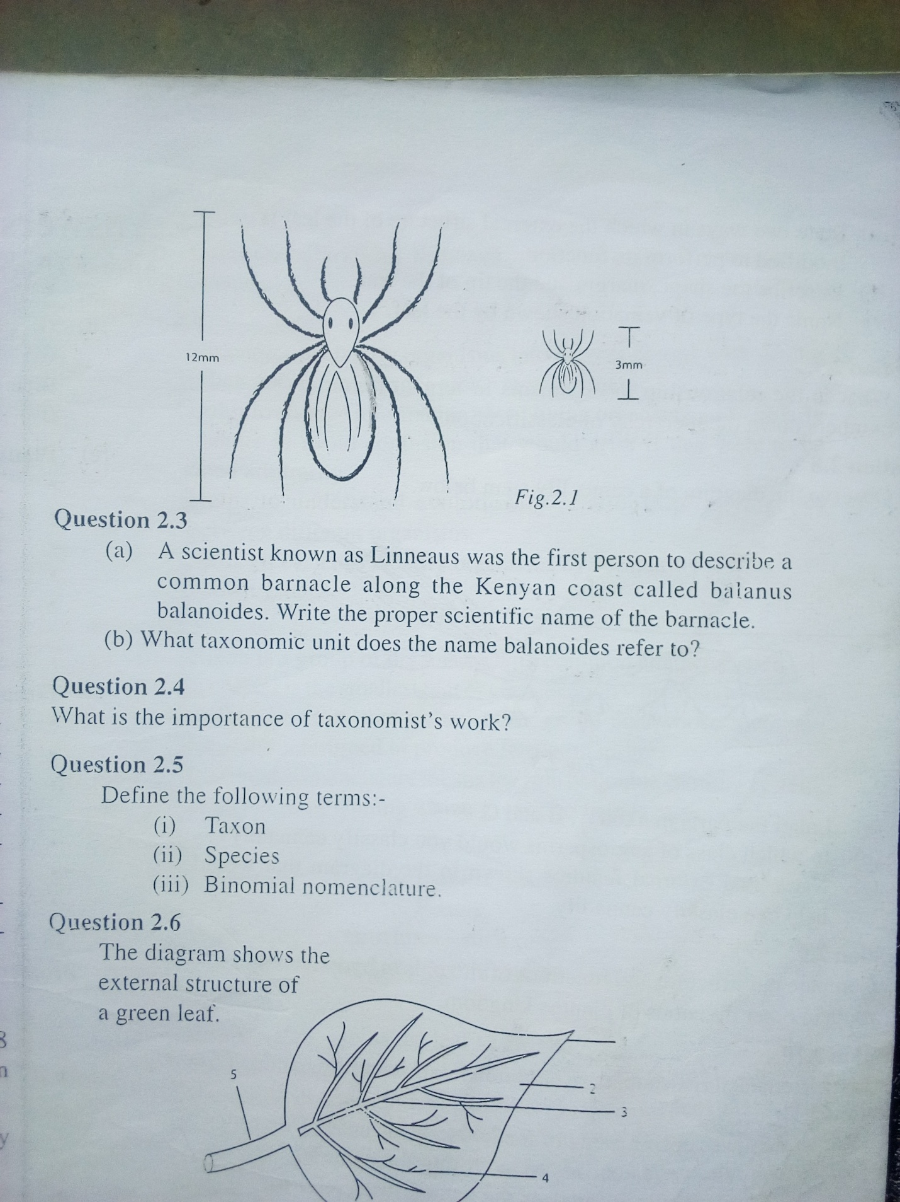

13. Observe the diagram of a canna lily stem below.

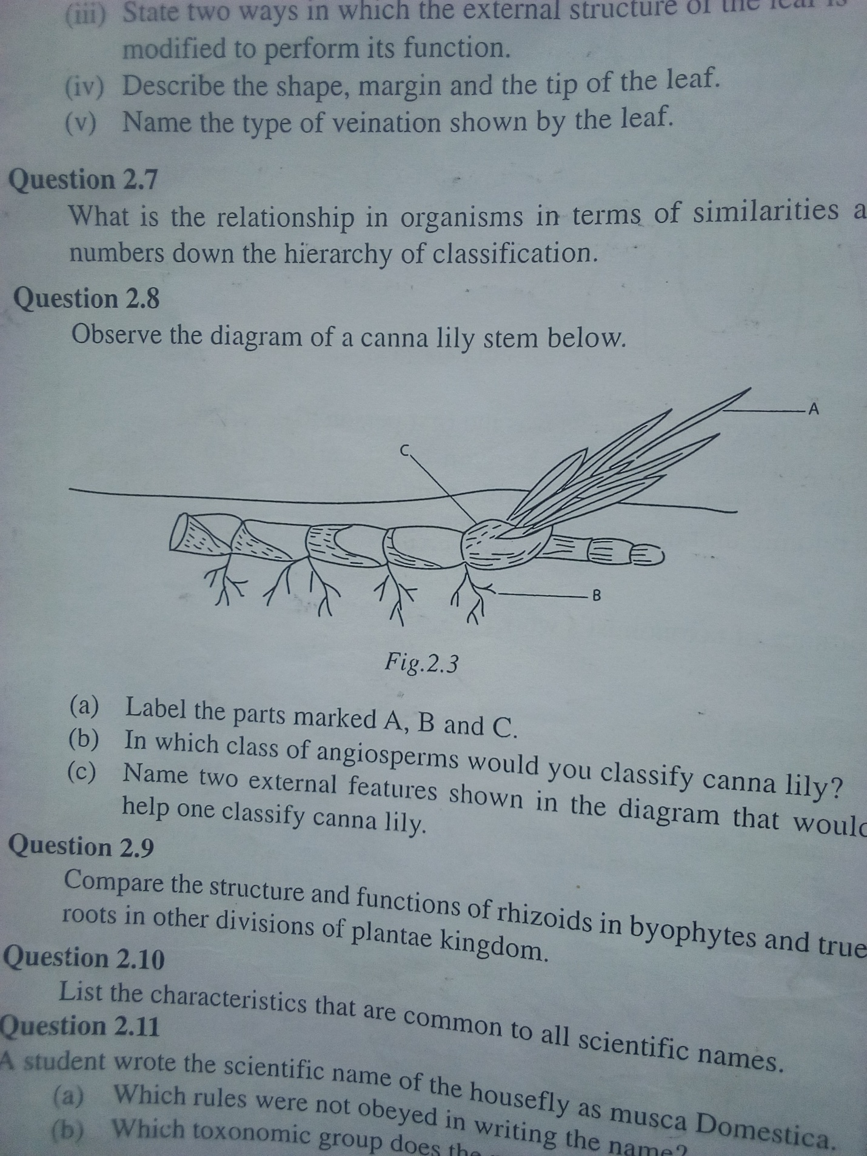

a. Label the parts marked A, B and C.

b.. In which class of angiosperms would you classify canna lily?

c. Name two external features shown in the diagram that would help one classify canna lily.

14. The following is a diagram of a columnar epithelial tissue.

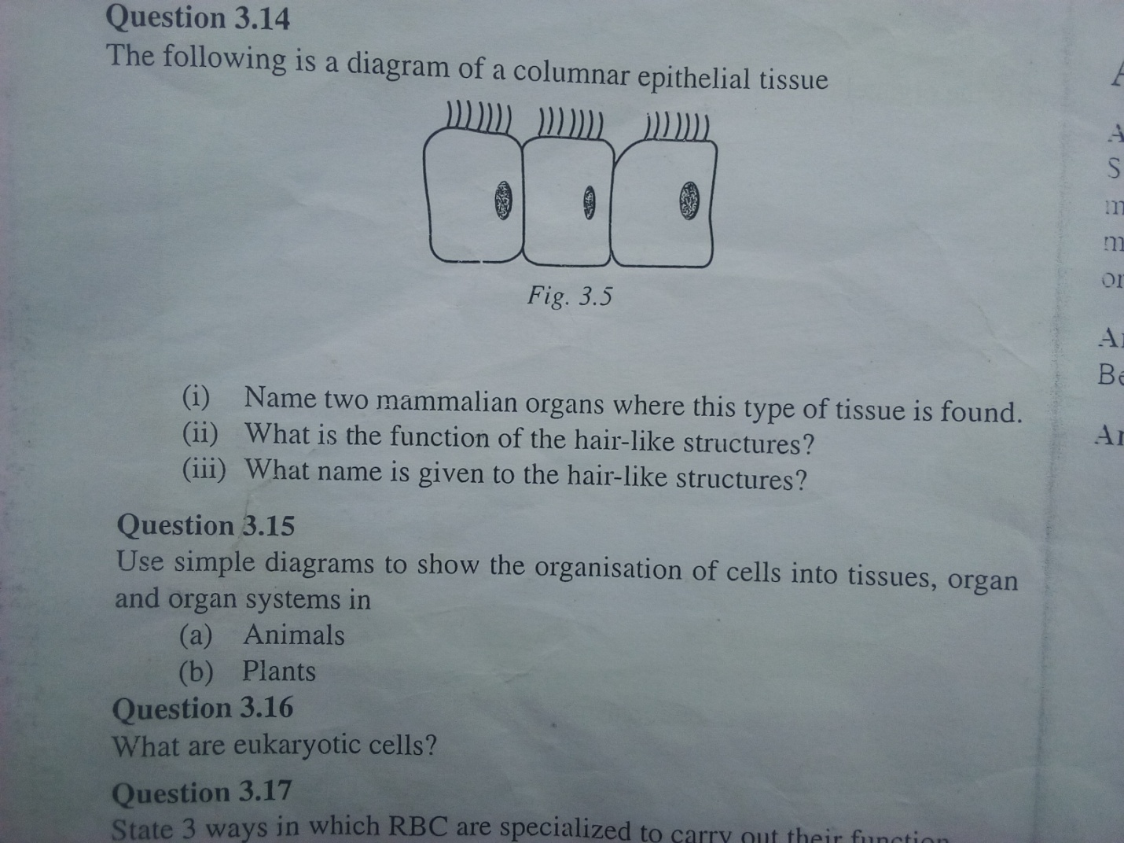

a. Name two mammalian organs where this type of tissue is found.

b. What is the function of the hair-like structures?

c. What name is given to the hair -like structures?

15.

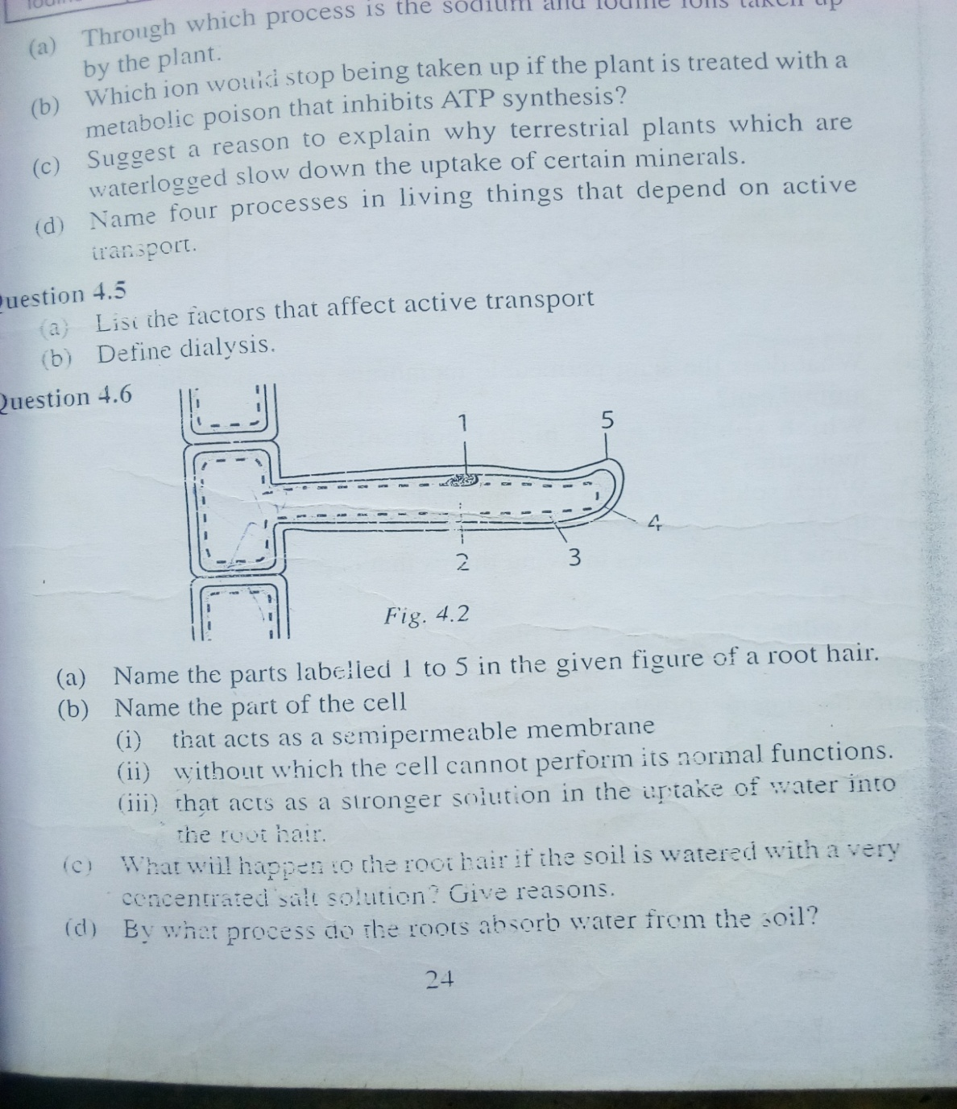

a. Name the parts labelled 1 to 5 in the given figure of a root hair.

b. Name the parts of the cell

i) that acts as a semi permeable membrane .

ii) without which the cell cannot perform its normal function.

iii) that acts as a stronger solution in the uptake of water into the root hair.

c. What will happen to the root hair if the soil is watered with a very concentrated salt solution? Give reasons.

d. By what process do the roots absorb water from the soil?

e. What the adaptations of root hair cells to perform their functions?

16. a. Explain how a plant benefits from transpiration.

b. Describe how plants in arid /dry areas control excessive loss of water.

17. a. Which food stuff in our diet supplies most heat per unit weight of food? Suggest a reason why this food-stuff releases most heat.

b. Name the apparatus used to measure the amount of energy per unit weight of any food stuff.

c. What is the final product of all carbohydrates?

d. What is the importance of carbohydrates in our body ?

e. List four foods rich in carbohydrates.

18. The diagram below represents a section through a leaf.

a. Name the parts labelled 1 to 10.

b. State a function of the parts labelled 1, 5, 6, 8 and 9.

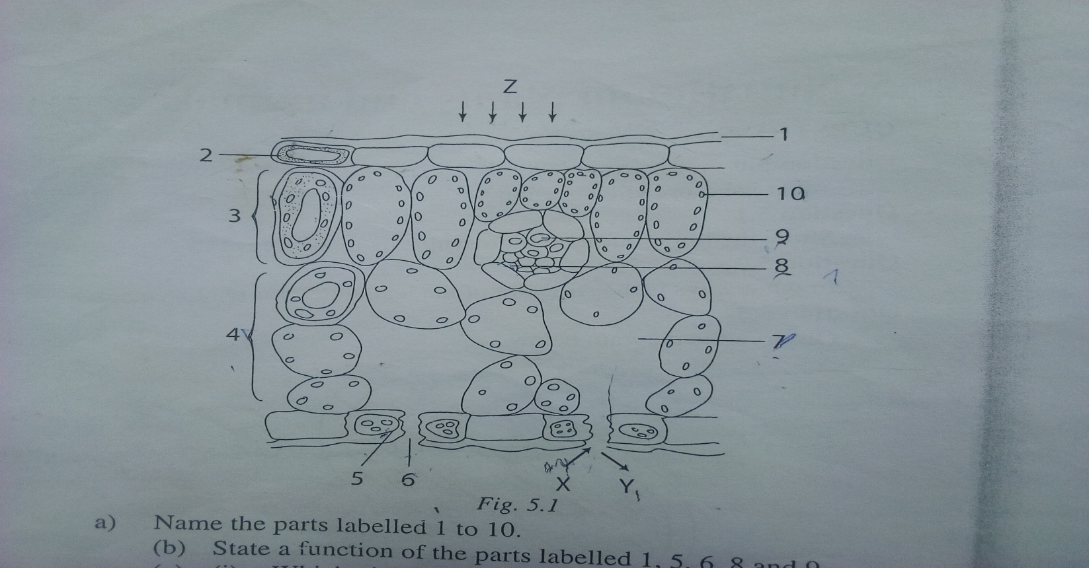

c. i) Which pigment is found in part labelled 10?

ii) State a function of that pigment.

iii) Write three different conditions each of which may cause a plant to fail to produce that pigment.

d. i) Name the gas X that enters the leaf during photosynthesis.

ii) Name the gas Y that leaves the leaf as by product of photosynthesis.

iii) Name the type of energy Z absorbed during photosynthesis.

e. Name the parts where photosynthesis is mainly carried out? Give two reasons

19. The following figures represent the parts of a mammalian skeleton.

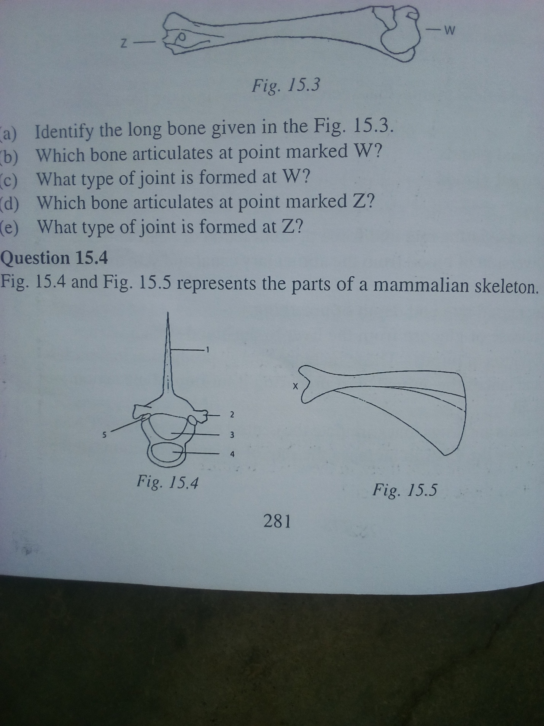

a. (i) Identify the bone given in the figure on the left side.

(ii) Name the parts labelled 1 to 5.

b. ( i) Identify the bone given in figure on the right side.

(ii) Name the long bone which articulates at X,

(iii) Name the type of joint formed at X.

c. In what ways are the first two cervical vertebrae specialized for their functions?

20. Figure below shows a structure in the mammalian lung, study the figure and answer the questions that follow:

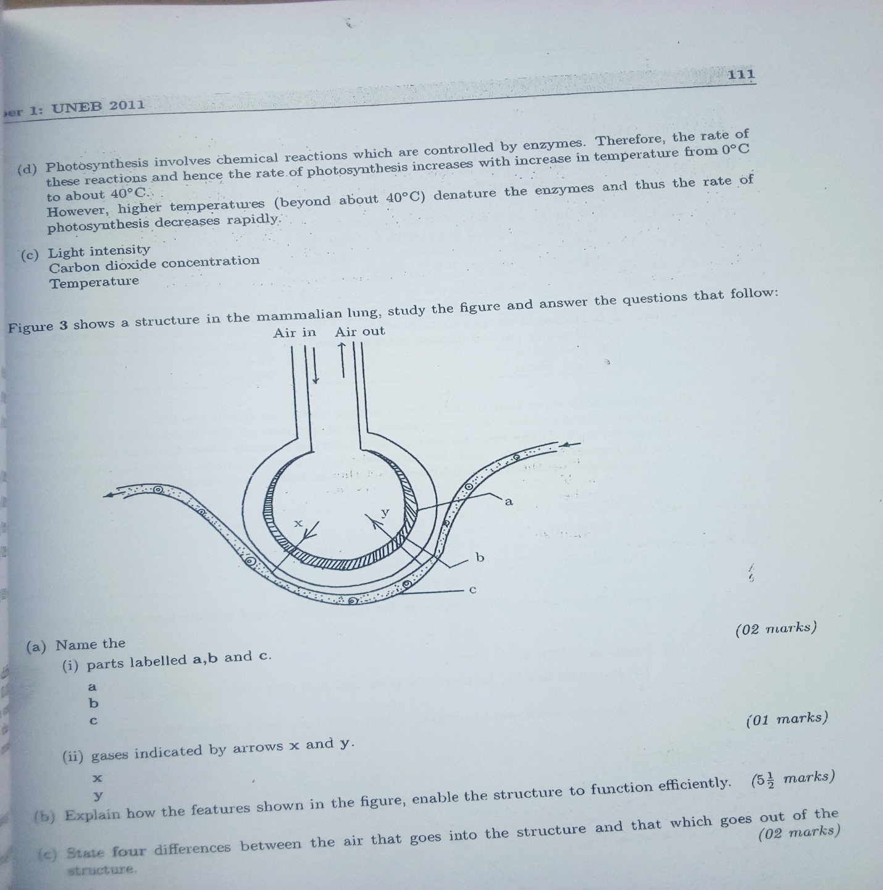

a) Name the

i) parts labelled a, b and C.

ii) gases indicated by arrows x and y.

b. Explain how the features shown in the figure enable the structure to function efficiently.

c. State four differences between the air that goes into the structure and that which goes out of structure.

e. How does the structure represented by the above figure adapt to its functions inside the lungs?

21. In an experiment some slices were cut from a living potato tuber and were immersed in distilled water for one hour. After that the slices were immersed in a concentrated salt solution for another one hour. The slices were taken out of the liquid, weighed and immersed again in the liquid at regular intervals.

The results are shown in the graph .Point L shows the beginning of the experiment.

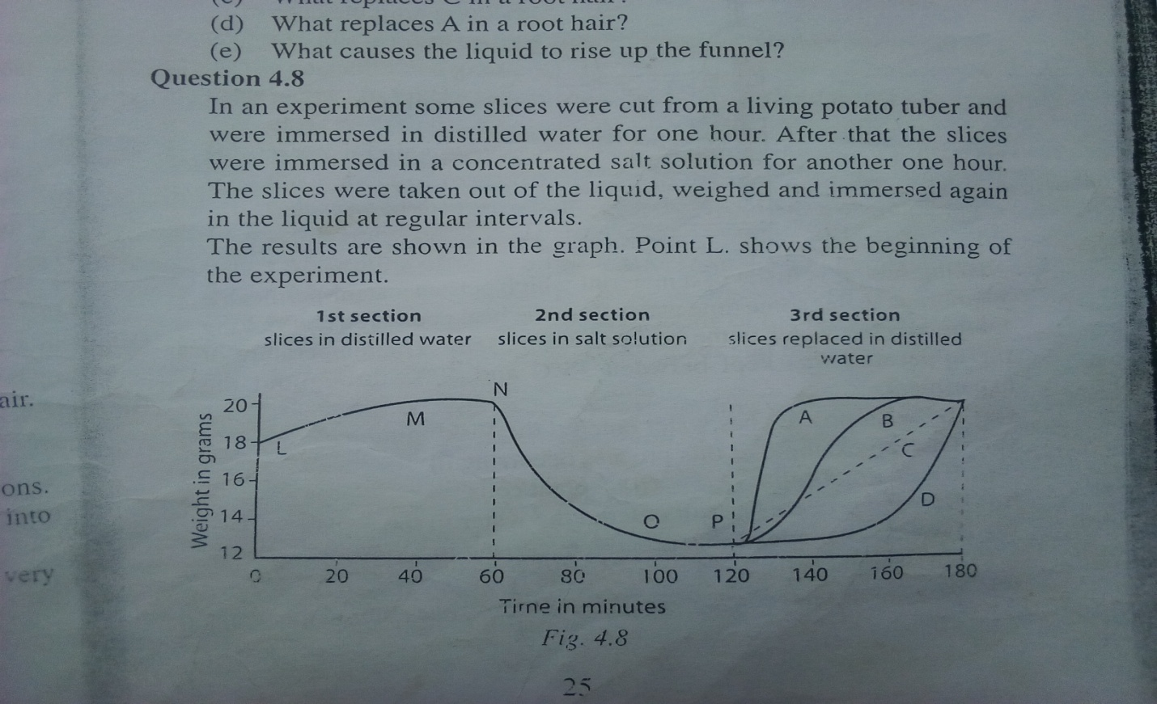

a. Describe the conditions of the cells of the slices at point L.

b. (i) Find the change in weight between L and M.

(ii) Which process brings about/causes this change in weight?

c. Describe the state of the cells of the slices at point N? Give reasons of your answer.

d. (i) Find the change in weight between N and O.

(ii) Which process brings about this change in weight?

e. The slices were removed from the concentrated salt solution at point P and washed in distilled water and were immersed in fresh distilled water. Four different lines A to D are drawn to show what would happen in the next one hour in the third section. Choose the correct one.

22. The diagram in the figure 8.1 shows the urinary system of a human female.

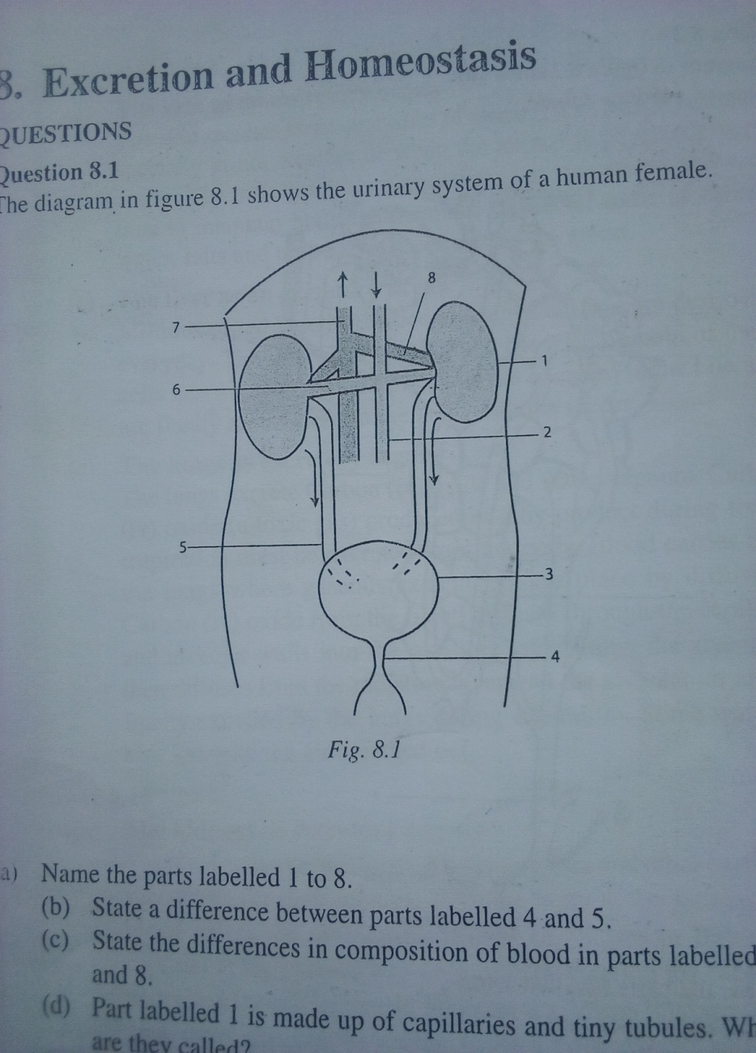

a. Name the parts represented by numbers from 1 to 8.

b. State a difference between parts labelled 4 and 5.

c. State the differences in composition of blood in parts labelled 6 and 8.

d. Part labelled 1 is made up of capillaries and tiny tubules. What are they caalles?

e. State two functions of part labelled 1.

f. Where is urine stored?

g. Urea is made in part .

A1. B.3 C. 3 D not shown .

23. ( a) Give four characteristics of enzymes.

( b) Describe an experiment to show that enzyme activity is affected by temperature.

24. Describe an experiment that you would carry out in the laboratory to test for the presence of a non-reducing (complex) sugar in a solution of a food sample. In your description , state the use of each reagent used.