**KIGALI CITY**

**ES KANOMBE/EFOTEC**

**SENIOR THREE**

**CHEMISTRY ACTIVITIES**

1. a. Draw a well labeled diagram that shows the preparation of dry carbon dioxide. You need the following compounds: calcium carbonate, dilute hydrochloric acid, water and concentrated sulphuric acid.

b. What is the role of water and concentrated sulphuric acid?

c. Write a balanced equation of the reaction showing the physical states of the reactants and the products.

d. Calcium carbonate was heated strongly to form a solid X and a colourless gas Y

i) Identify substances X and Y

ii) The gaseous product Y was then passed through lime water, first in small amounts and

later in excess. Explain what is observed by using chemical equations.

1. No one knows where iron was first isolated. It appeared in China, the Middle East and in Africa. It was obtained by reducing iron ore with charcoal.
2. Complete the following equation.

Fe2O3 + C →................... + ........................

1. **I**ron ore could be reduced using coke in a blast furnace.
2. The temperature in the furnace rises to 2000 °C. Write an equation for the exothermic reaction that causes this high temperature.
3. In the furnace, the ore is reduced by carbon monoxide. Explain how this is formed.
4. The formation of slag removes an impurity in the ore. Write a word equation for the formation of the slag.
5. Give at least one hazard of extraction of iron.
6. The equation below represents the reaction between calcium carbonate and dil. HCl acid.

CaCO3 + 2HCl → CaCl2 + H2O + CO2

1. What observations would be made when
2. Dilute HCl acid is added to calcium carbonate.
3. Dilute sulphuric acid is added to calcium carbonate
4. What would be observed when calcium carbonate is dissolved in;
5. Water which contains dissolved carbon dioxide
6. Write the reaction in (i) above and name the product formed.
7. What is the temporary hard water?

4. Iron ore, coke, limestone and air are the main raw materials in blast furnace for the extraction of iron. The reducing agent in the process is carbon (II) oxide.

a) Explain how carbon (II) oxide is produced

b) Give equations for the reaction in which iron is formed.

c) What is the importance of limestone?

5. Explain the following:

* 1. Carbon (II) oxide is a more dangerous and poisonous gas compared to other gases.
  2. Carbon (IV) oxide is used in fire extinguishers.
  3. Carbon (IV) oxide when bubbled through limewater forms a white precipitate and on passing in excess the precipitate dissolves.

6. In the laboratory carbon (IV) oxide is usually prepared by the action of dilute hydrochloric acid on marble chips.

a) Write an ionic equation for the reaction that takes place.

b) Explain why it is not advisable to use silver carbonate instead of marble chits in the above reaction.

7. Study the flow chart below and answer the questions that follow.

Carbon (IV) oxide + water ⇄ Acid A

Burning magnesium

White solid B + black specks

Water

Alkaline solution C

Write the formula of substances A, B and C

8. It is not advisable to sleep inside a house which is not well ventilated with a burning wooden charcoal. Give a reason for that and write the chemical equation to represent your answer.

9. Incomplete combustion of carbon produces carbon monoxide. Carbon monoxide is also produced by a charcoal stove when there is insufficient air (oxygen)

a) Why is carbon monoxide poisonous when it is inhaled (breathed)?

b) Write a balanced equation for the reaction between carbon and oxygen.

c) Carbon monoxide act as reducing agent, write any equation that illustrate this property.

10. Nitrogen dioxide, NO2, is a dark brown gas.

a)Most metal nitrates decompose when heated to form different products. Write a symbol equation for the decomposition of lead (II) nitrate.

b)Nitrogen dioxide, oxygen and water react to form dilute nitric acid. Write a balanced equation for this reaction

c)Describe how lead (II) nitrate crystals could be prepared from lead (II) oxide.

11. a) Draw a diagram of the structure of an atom of nitrogen (Z=7)

b) What role do the following substances play in the preparation of nitrogen from air?

i) Concentrated KOH solution

ii) Copper turnings

c) State three differences between the physical properties of nitrogen gas and nitrogen dioxide gas.

12. a) Draw the diagram which show the apparatus set up to prepare ammonia gas from ammonium chloride and calcium hydroxide.

b) Write the equation for the reaction

c) i) Which other ammonia salt can be used in place of ammonium chloride?

ii) how can you show that ammonia is an alkaline gas?

iii) State three large scale uses of ammonia.

13. The flow chart below shows the process that can be used to obtain substance C from ammonia gas when it is heated to about 900 in air and in the presence of a catalyst.

A

Ammonia

B Substance C

a) Ammonia is obtained on large scare by Haber process. Name the raw materials A and B.

b) Name the substance C and the catalyst used.

c) Write an equation to show the product formed when C is cooled in presence of air.

14. Ammonia gas in solution dissociates according to the equation below.

1. Identify the acidic species in the above equation. Explain
2. Write the formula of the complex ion formed when ammonia is added to copper II sulphate solution until in excess.

15. In an experiment, ammonia gas was prepared by heating an ammonium salt with an alkali. After drying 120cm3 of ammonia gas were collected at room temperature and pressure.

a) Define the term alkali.

b) Ammonia gas is dried using calcium oxide and not calcium chloride or concentrated sulphuric acid. Explain.

16.The catalytic combination of hydrogen gas and nitrogen gas to produce ammonia is represented by the following equation.

a) Name the catalyst and that can be used in this reaction

b) Give the test for identification of ammonia gas.

17. Study the flow chart below and answer the questions that follow.

N2(g)

Colorless gas B

H2 (g)

Catalyst C + O2

1. Name catalysts A, C and colorless gas B
2. Write the equations for the reactions in steps I to IV.
3. State two industrial uses of nitric acid.

18. Ammonia is manufactured from nitrogen and hydrogen in the Haber Process. The diagram  
shows some details of the manufacturing process.  
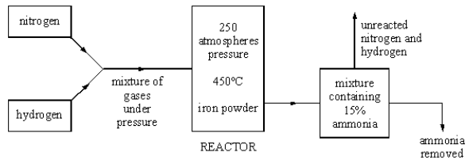

(a) Nitrogen is obtained from the air.  
From where is the hydrogen obtained?  
(b) What happens to the unreacted nitrogen and hydrogen?  
(c) Ammonium nitrate is made from ammonia.  
Farmers spread nitrates on to soil to make crops grow better.  
The nitrates may get into people’s bodies even if they do not eat the crops.  
Explain how this can happen.

19. Ammonia is manufactured by the Haber Process, where nitrogen and hydrogen react  
together as follows:  
N2 + 3H2 → 2NH3  
The reaction is reversible. A balance is eventually reached when ammonia is being formed at  
the same rate at which it is decomposing.  
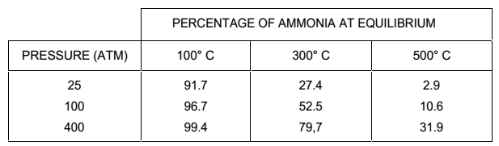

(a) (i) What is meant by a ‘reversible reaction’?

(b) (i) Under what conditions shown in the table is the maximum yield of  
ammonia obtained?  
(ii) The Haber Process is usually carried out at a higher temperature than that which  
would produce the maximum yield. Suggest why.

(C) Plot the graph that show the percentage yield of ammonia against pressure.

20. The chart shows the processes involved in the manufacture of nitric acid from ammonia.  
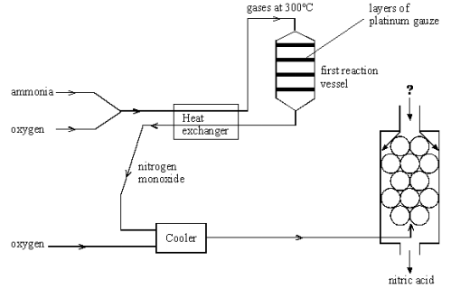

(a) Write the equation for the reaction that takes place in the first reaction vessel.  
(b) What is the use of the platinum gauze in the reaction vessel?  
(c) To convert nitrogen monoxide into nitric acid, **two** further reactants are needed.  
What are they?  
(d) write equation that show how you make the ammonium nitrate fertiliser.