**BIOLOGY HOLIDAY ACTIVITY FOR S4**

Q1. Look carefully the specimen below:



a) To which kingdom do the following organisms belong? **/2mks**

b) Make a dichotomous key for these animal specimen. **/5mks**

Q2. The following is a list of organisms belonging to various kingdoms and phyla.

a) Housefly (*Musca domestica*)

b) *Zea mays* (maize)

c) Bread mold (Rhizopus)

*d) Tilapia zillii*

*e) Tilapia variabilis*

f) Eagle

i. Classify these organisms into their kingdoms. **/3mks**

ii. Name the two organisms that are most closely related. Give a reason. **/3mks**

iii. What is the genus of the housefly? **/1mk**

iv. What does the name *mays* represent? **/1mk**

Q3. A sample was made of the animals living on two forests. 10 quadrats were placed on each forest, and the number of animals of each species in each quadrat was counted.

The results are shown in the table.

|  |  |  |  |
| --- | --- | --- | --- |
| **Species** | | **Number of individuals, n** | |
| **Forest A** | | **Forest B** | |
| Lions | 14 | | 51 |
| Rats | 85 | | 125 |
| Zebra | 63 | | 63 |
| Cheetah | 0 | | 0 |
| Eagles | 22 | | 22 |
| Bats | 91 | | 391 |
| Snails | 36 | | 116 |
| Snakes | 53 | | 93 |
| Total number of individuals, N | 364 | | 861 |

a) Determine the Simpson’s index of diversity for forest A and forest B.

b) Which forest has a high biodiversity? Why?

c) Differentiate between species richness and species evenness.

Q4. Complete the table below to place the levels of organization in the correct order, where 1 is the lowest and 5 is the highest. Two have been done for you. Give an example of each of the five levels. One has been done for you.

|  |  |  |  |  |  |  |  |
| --- | --- | --- | --- | --- | --- | --- | --- |
|  | |  | | |  | | |
| **Level of organization** |  | | **Order** | | | **2 examples** | | |
| Cell |  | | | 2 | | |  |
| Organ |  | | | 4 | | |  |
|  |  | | |  | | |  |
| Organelle |  | | | | | |  |
| System |  | | | | | |  |
|  |  | | | | | |  |
| Tissue |  | | | Mesophyll | | |  |

Q5. The table below shows some features that may or may not be present in four main groups of organisms. Complete the table to match the features to the groups. Write **Always** if they all have the feature, **Never** if none of them have the feature or **Sometimes** if some examples have the feature and some do not.

|  |  |  |  |  |  |
| --- | --- | --- | --- | --- | --- |
| **Group** |  | **Are multicellular** | **Have cell walls** |  | **Can carry out** |
|  |  |  |  |  | **photosynthesis** |
| Plants |  | | Always |  | |
| Animals |  | | Always |  | |
| Fungi |  | | Sometimes |  | |
| Bacteria |  | | Always |  | |

Q6. The figure below shows a section in an animal cell



a) What are the organelles represented by the letters A, B, C and D?

b) What is the functional relationship between the organelles B, C and D?

c) In which organelle is DNA located in the cell?

d) Which other organelles are found in eukaryotic cells and contain DNA?

Q7. a) Explain the difference between species richness and species evenness.

b) Explain how a habitat with high diversity tends to be more stable than one with low diversity.

Q8. Evaluate the contribution of biodiversity to human wellbeing.

Q9. a) Explain the difference between taxonomy and classification.

b) Why do we study how closely related we are to other organisms?

Q10.The diagram below shows how organisms may be separated into five kingdoms.



a) i) Name Kingdom B.

ii) Give one characteristic, other than the possession of chloroplasts, which could be used to distinguish cells of organisms in Kingdom B from those in Kingdom C.

b) Which of the Kingdoms A, B, C, D or E represents the Fungi?

c) Microactinium is a single-celled eukaryotic organism. It is an autotroph. Which of kingdoms A, B, C, D, or E includes Microactinium?

Q11. a) Differentiate between a bacteriophage and a retrovirus?

b) Do you think viruses should be considered as a form of life? Give reasons for your answer.

Q12. a) What are the four main things that all members of a species share?

b) What are the three features of a natural system of classification?

Q13. A species may be defined in terms of observable similarities and ability to produce fertile offspring.There are however problems when using this definition in practice.

1. Even where groups of extinct organisms have left fossil records, it is very difficult to distinguish different species. Suggest two reasons why?
2. Suggest reasons why it is often difficult to classify organisms as distinct species.

Q14. a) Explain why using common names for living organisms can cause confusion.

b) Why do we need to identify living things

Q15. Contrast how an optical microscope and transmission electron microscope work and contrast the limitations of their use when studying cells.

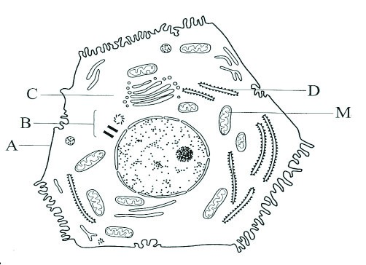Q16. The figure below show the structure of Liver cell, as seen using electronic microscopy.

a. Name the structure labelled A, B, C and D

b. What do you think about the presence of numerous mitochondria in the liver cells?

c. Explain the advantage to have a division of labor between different cells in the body.

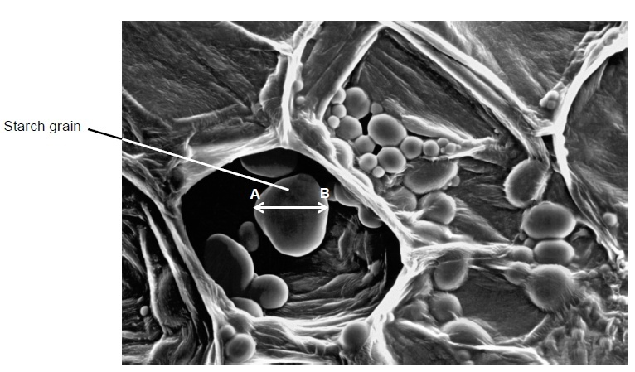Q17. The figure below shows a section through a plant tissue at a magnification of ×500.

1. Calculate the actual diameter of the starch grain between points A and B.
2. What type of microscope was used to obtain the image shown in Figure ?
3. Give one piece of evidence to support your answer.
4. Type of microscope:--------------------------------------------
5. Evidence :---------------------------------------------

18. a) Copy and complete the table comparing bacteria and viruses.Using a () if the feature is present or a (x) if the feature is absent.

|  |  |  |  |
| --- | --- | --- | --- |
|  | **Protein** | **Ribosomes** | **Mitochondria** |
| Bacteria |  |  |  |
| viruses |  |  |  |

b) Describe one method by which viruses can be cultured.

Q19. a) Copy and complete the table below which compares the structures of a typical plant, animal and prokaryotic cell. Use tick (√) if the feature is present and a cross (X) if it is absent.

|  |  |  |  |
| --- | --- | --- | --- |
|  | **Plant cell** | **Animal cell** | **Prokaryotic cell** |
| Nucleus |  |  |  |
| Plasmid |  |  |  |
| Mitochondrion |  |  |  |
| Cellulose wall |  |  |  |

b) Mitochondria and chloroplasts contain small loops of DNA. They also contain ribosomes that are the same size as prokaryotic ribosomes. Suggest an explanation for these features

Q20. 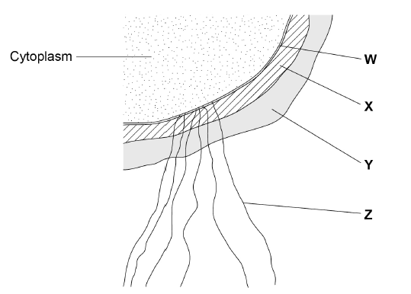The figure below shows the parts of a prokaryotic cell.

a) Name the structures labelled W to Z .

b) Name the main biological molecule in:

W-------------------------------

X---------------------------------

Q21. a) Explain why differentiation to produce erythrocytes involves a change in shape.

b) Red blood cells cannot divide as they have no nucleus. State two other processes that red blood cells cannot carry out.

c) Describe how the following are specialized for their role:

1. Neutrophil,
2. sperm
3. root hair.

Q22. Using the following leaves, construct a dichotomous key and show all the steps followed for the identification of each.

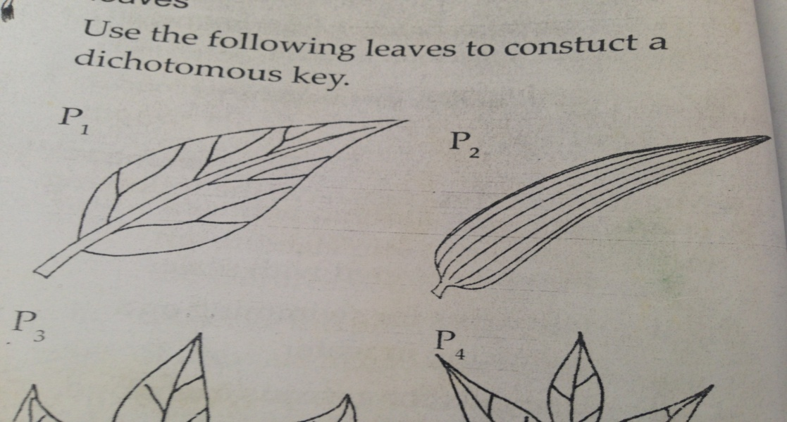

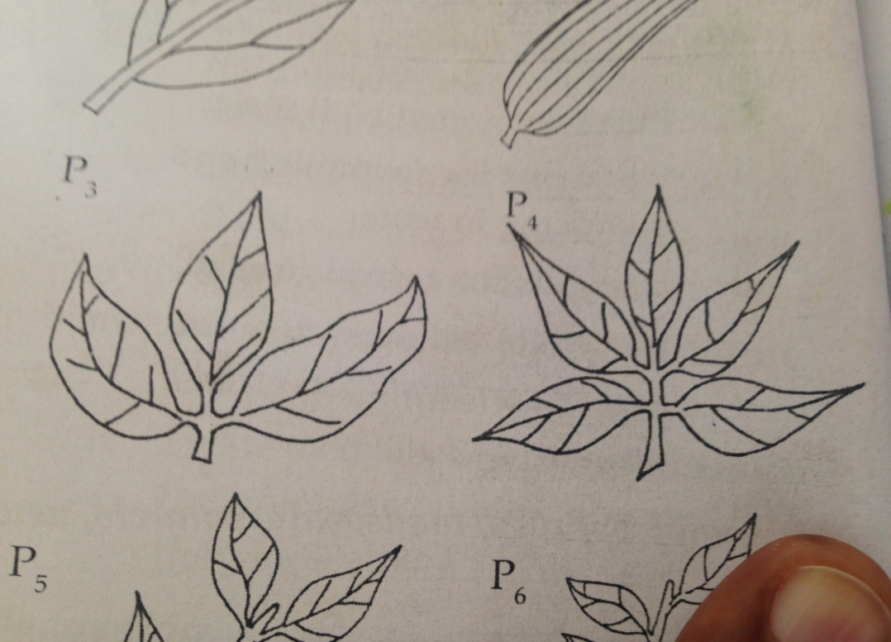

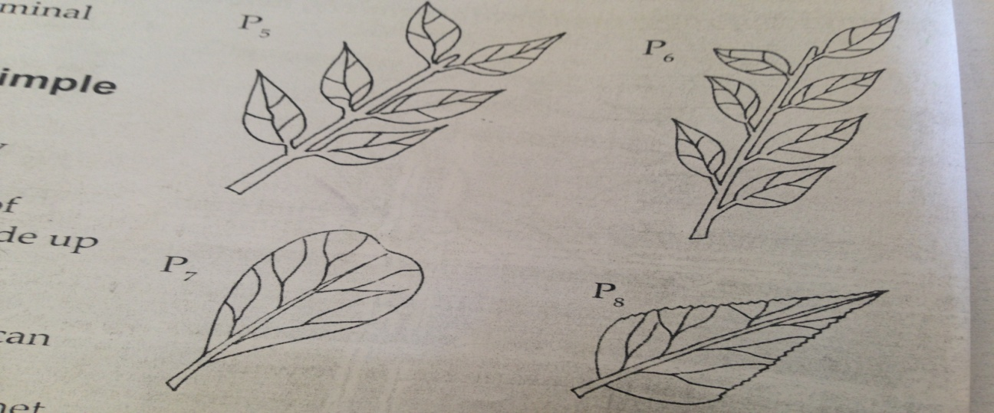

--------------------------------------------------END----------------------------------------------------------